|  |  |  |  |  |
| --- | --- | --- | --- | --- |
|  |  | | |  |
|  |  | | |  |
|  | Ultimate Remote Control  <<Feature>>  (F003071) | | |  |
|  |  | | |  |
| Document Type | **Feature Document (FD)** | | |  |
| Template Version | **6.0b / FFSD 7.1** | | |  |
| SysML Report Template Version | **O Beta (7/25/2019)** | | |  |
| Document ID | **ffst01.10_featuredocument_sysmlreporttemplate** | | |  |
| Document Location | **VSEM** | | |  |
| Document Owner | **Reed, Gregory (G.D.) (greed29)** | | |  |
| Document Revision | **FD REV 02** | | |  |
| Document Status | **UVP1** | | |  |
| Date Issued | **2021-06-02** | | |  |
| Date Revised | **2021-06-02** | | |  |
| Document Classification | GIS1 Item Number: | **27.60/35** | |  |
| GIS2 Classification: | **Confidential** | |
|  | | | | |
|  | | | | |
| Document Approval | | | | |
| Person | Role | | Email Confirmation | Date |
|  |  | |  |  |
|  |  | |  |  |

**Auto-Generated by MagicDraw**

Printed Copies Are Uncontrolled

# Disclaimer

**This document contains Ford Motor Company Confidential information. Disclosure of the information contained in any portion of this document is not permitted without the expressed, written consent of a duly authorized representative of Ford Motor Company, Dearborn, Michigan, U.S.A.**

**Copyright, Ó 2016 Ford Motor Company**

This document contains information developed and accumulated by and for FORD MOTOR COMPANY. As such, it is a proprietary document, which, if disseminated to unauthorized persons, would provide others with restricted information, data, or procedures not otherwise available, exposing the FORD MOTOR COMPANY to potential harm.

Employees and suppliers having custody of this specification or authorized to use it must be cognizant of its proprietary nature and ensure that the information herein is not made available to unauthorized persons.

FORD MOTOR COMPANY reserves the right to protect this work as an unpublished copyrighted work in the event of an inadvertent or deliberate unauthorized publication. FORD MOTOR COMPANY also reserves its rights under copyright laws to protect this work as a published work.

This document or portions thereof shall not be distributed outside FORD MOTOR COMPANY without prior written consent. Refer all questions concerning disclosure to the author(s) or to any duly authorized representative of Ford Motor Company.

# Contents

1.1.2 Decomposition of Functional Safety Requirement 13

Disclaimer 22

Contents 23

2 Introduction 26

2.1 Document Purpose 26

2.2 Document Scope 26

2.3 Document Audience 26

2.3.1 Stakeholder List 26

2.4 Document Organization 26

2.4.1 Document Context 26

2.4.2 Document Structure 27

2.5 Document Conventions 27

2.5.1 Requirements Templates 27

3 Feature Overview 28

3.1 Purpose and Description of Feature 28

3.2 Feature Variants 28

3.2.1 Regions & Markets 29

3.3 Input Requirements 29

3.3.1 Legal Requirements 30

3.3.2 Trustmark Requirements 30

3.3.3 Industry Standards 30

3.3.4 Attribute Requirements 30

3.4 Lessons Learned 30

3.5 Assumptions 31

3.6 References 31

3.6.1 Ford Documents 32

3.6.2 External Documents and Publications 32

3.7 Glossary 33

3.7.1 Parameters / Values 33

4 Feature Context 34

4.1 Feature Context Diagram 34

4.2 List of Influences 34

5 Feature Modeling 36

5.1 Operation Modes and States 36

5.2 Use Cases 38

5.2.1 Use Case Diagram 38

5.2.2 Actors 39

5.2.3 Use Case Descriptions 39

5.3 Driving and Operation Scenarios 43

5.4 Decision Tables 45

6 Feature Requirements 46

6.1 Functional Requirements 46

6.1.1 Error Handling 47

6.2 Non-Functional Requirements 47

6.2.1 Safety 47

6.2.2 Security 47

6.2.3 Reliability 47

6.3 HMI Requirements 47

6.4 Other Requirements 48

6.4.1 Design Requirements 48

6.4.2 Manufacturing Requirements 48

6.4.3 Service Requirements 48

6.4.4 After Sales Requirements 48

6.4.5 Process Requirements 48

6.4.6 Uncategorized Requirements 49

7 Functional Safety 50

7.1 System Behaviors for HARA 50

7.2 Safety Assumptions 50

7.3 Safety Goals 51

7.4 Functional Safety Requirements 53

7.4.1 Safety Goal: 53

7.4.2 Derivation of Functional Safety Requirements on Assumptions 55

7.5 ASIL Decomposition of Functional Safety Requirements 56

8 Architecture 57

8.1 Functional Architecture 57

8.1.1 List of Functions 57

8.2 Logical Architecture 58

8.2.1 Logical Interfaces 59

9 Open Concerns 61

10 Revision History 62

11 Appendix 63

11.1 Definitions 63

11.2 Abbreviations 63

**List of Figures**

Figure 1. 12

Figure 2: 28

Figure 3: - 28

Figure 4: 34

Figure 5: 36

Figure 6: 38

Figure 7:  55

Figure 8: 57

Figure 9: 58

**List of Tables**

Table 1: Features described in this FD 26

Table 2: Feature Variants 29

Table 3: Regions & Markets 29

Table 4: Ford internal Documents 32

Table 5: Ford internal Documents *(not specified in SysML model)* 32

Table 6: External documents and publications 32

Table 7: External documents and publications *(not specified in SysML model)* 33

Table 8: Parameters / Values used in this document *(Not supported by MagicDraw report generation)* 33

Table 9: List of Influences 35

Table 10: Operation Modes and States on 36

Table 11: Transitions between Operation Modes and States on 38

Table 12: List of Actors 39

Table 13: System Behaviors for HARA 50

Table 14: Functional Safety Assumptions 51

Table 15: Functional Safety Goals 53

Table 16: List of Functions 58

Table 17: List of Functions on 58

Table 18: Feature Interactions 59

Table 19: Feature Interactions on 59

Table 20: Open Concerns *(Not supported by MagicDraw report generation)* 61

Table 21: Definitions used in this document 63

Table 22: Abbreviations used in this document 64

# Introduction

## Document Purpose

A Feature Document (FD) document specifies **what** the feature shall do and how it shall behave from customer perspective. It should also provide reasoning and background **why** we have the feature in the vehicle.

The FD also serves as an Item Definition as defined by ISO26262 for those features, which follow the Ford Functional Safety process.

To get more information about the concept of feature, function and component level abstraction refer to the [Ford RE Wiki](http://wiki.ford.com/display/RequirementsEngineering/Requirements+Engineering+for+SW+Enabled+Features). For details on the Ford Functional Safety (ISO26262) process refer to the [Ford Functional Safety Sharepoint](https://pd3.spt.ford.com/sites/GlobalFunctionalSafety/Pages/default.aspx).

## Document Scope

This Feature Document (FD) specifies the following features:

|  |  |  |  |
| --- | --- | --- | --- |
| **Feature ID** | **Feature Name** | **Owner** | **Reference** |
| F003071 | Ultimate Remote Control | Reed, Gregory (G.D.) (greed29) |  |

Table 1: Features described in this FD

## Document Audience

The FD is written by the feature owner of Reed, Gregory (G.D.) (greed29). All Stakeholders, i.e., all people who have a valid interest in the feature should read and, if possible, review the FD. It needs to be guaranteed, that all stakeholders have access to the currently valid version of the FD.

**#Hint:** The FD template has the IP Classification “Proprietary” by default. IP Classification “Confidential” might be required in some cases, e.g. by Ford Functional Safety.

### Stakeholder List

For the latest list of stakeholder of the feature and their influence refer to <Put VSEM Link here>.

<https://www.vsemweb.ford.com/tc/launchapp?-attach=true&-s=226TCSession&-o=C$pBjd1Gx3NrTDAAAAAAAAAAAAA&servername=Production_Server>

**#Hint:** Refer to [Ford RE Wiki – Stakeholder List](http://wiki.ford.com/display/RequirementsEngineering/Stakeholder+Analysis) on how to create a stakeholder list. The stakeholder list should be stored in VSEM in the pseudo folder “General Data Artifacts” of the corresponding feature.

## Document Organization

### Document Context

Refer to the [Specification Structure page](http://wiki.ford.com/display/RequirementsEngineering/Specification+templates) in the [Ford RE Wiki](http://wiki.ford.com/display/RequirementsEngineering/Requirements+Engineering+for+SW+Enabled+Features) to understand how the FD relates to other Ford Requirements Documents and Specifications.

### Document Structure

The structure of this document is explained below:

**Section 1** – Introduction how to use this document including responsibilities and requisite documents. Explains the terminology. Gives a clarification of the definitions, concepts and abbreviations used in the document.

**Section 2** – Feature Description. States briefly the background and the purpose of the feature, feature variants and corresponding regions and markets. Also includes input requirements, assumptions and constraints.

**Section 3** – Feature Context describes all external entities, which have an influence on the feature.

**Section 4** – Feature Modeling. Contains Use Case, Driving Scenarios, State Charts to describe the functional behavior of the feature.

**Section 5** – Safety. Lists System Behaviors and Safety Goals of the feature.

**Section 6** – Feature Requirements. Lists functional and non-functional requirements of the feature.

**Section 7** – Architecture. Shows the coarse architecture, which the feature requirements are deployed to. Describes the elements and the boundary of the feature as well as the decomposition and distribution of associated functions.

**Section 8** – List of Open Concerns

**Section 9** – Document Change History including a list of new or modified requirements. The requirements in this document are tagged, and this section contains different types of tables listing all, new, or changed requirements by their title and page no.

**Section 10** – Appendix

**#Hint:** All sections are mandatory, unless explicitly marked by the tag “#Classification” as “optional” or as applicable e.g. to certain domains like “Functional Safety”.

## Document Conventions

### Requirements Templates

Each requirement, use case or scenario in this specification shall follow the corresponding template given in the document template *Specification_Macros.dotm* at [RE Wiki - Specification Templates](http://wiki.ford.com/display/RequirementsEngineering/Specification+templates?src=contextnavpagetreemode).

#### Identification of requirements

#### Requirements Attributes

The templates provided by *Specification_Macros.dotm* define a list of attributes for each requirement. This helps to classify the requirement. The attributes are explained at [RE Wiki - Requirements Attributes](http://wiki.ford.com/display/RequirementsEngineering/Requirements+Attributes?src=contextnavpagetreemode).

## References

### Ford Documents

List here all Ford internal documents, which are directly related to the feature.

| **Reference** | **Title** | **Doc. ID** | **Document Location** | **Revision** |
| --- | --- | --- | --- | --- |
| Attribute Release Letter (ARL) | MUC Orchestration | RQT-002004-712583 | FEDE | 2 |
|  | URC Cyber Security Requirements | VDOC094676 | VSEM | 2 |
|  | My Seat Space Feature Document | F003519 | VSEM | 1 |
|  | Rear Seat Controls Lockout Feature Document | F003110 | VSEM | 1 |

Table 5: Ford internal Documents *(not specified in SysML model)*

### External Documents and Publications

The list of external documents could include books, reports and online sources.

**#Hint:** You may refer to [IEEE Citation Reference](http://www.ieee.org/documents/ieeecitationref.pdf) on how to format a reference.

| **Reference** | **Document / Publication** | **Document Location** |
| --- | --- | --- |
|  |  |  |

Table 7: External documents and publications *(not specified in SysML model)*

## Glossary

**#Hint**: Terms, concepts and abbreviations used in the document shall be defined and illustrated here. Note that changes to terms and/or concepts described in this section tend to cause major updates to this document.

The tables below have feature specific definitions and abbreviations. For additional, non-feature specific terms please refer to the [RE Glossary](http://wiki.ford.com/display/RequirementsEngineering/Glossary?src=contextnavpagetreemode)

See Appendix for Definitions and Abbreviations.

### Parameters / Values

| **Name** | **Description** | **Range / Resolution** |
| --- | --- | --- |
|  |  |  |

Table 8: Parameters / Values used in this document *(Not supported by MagicDraw report generation)*

# Feature Overview

## Purpose and Description of Feature

**#Hint:** Some descriptive text to explain the purpose and functionality of the feature.

URC Feature allows the passengers control of their environment inside the vehicle for each individual seating zone.

It is simple and centralized way for first row, second, and third row passenger(s) to control their own seat functions (position, heat/vent, massage), zone climate adjustments, sound/audio, and lighting via Hand Held Device (HHD).

* The HHD will connect with the vehicle

* The URC User(s) will select which seat/area zone they are sitting in and take control for their seating zone

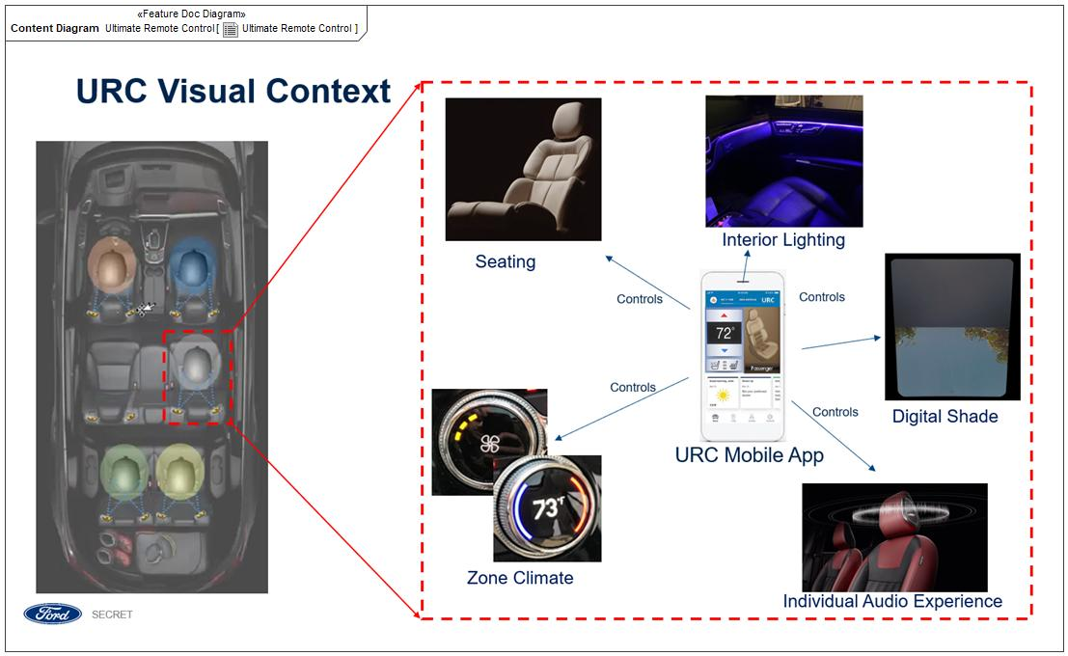

Figure 2: Ultimate Remote Control

## Feature Variants

**#Hint:** Definitions for different variants of the feature (if applicable). Give each variant a descriptive name by which it can be referenced further on in the document. If no variant exists, state “No Feature Variants”.

The Variant Description should give a short informative text which describes the variants of the feature.

|  |  |  |
| --- | --- | --- |
| **Variant Name** | **Variant Description** | **Remarks** |
| **URC** | The Ultimate Remote Control Feature stand alone | Controls Global Audio  *Driver can use URC App on Hand Held Device only when the vehicle is stationary (MY24 CDX747/746 not implementing driver URC HHD device controls)  *1R/2R/3R Passengers can use URC App on HHD when Sync is fully booted and Driver accepts connection request on infotainment system HMI |
| **URC With MSS** | The Ultimate Remote Control Feature will include controlling the My Seat Space Feature (MSS) | Controls Individual Seat Audio  *Driver can use URC App on Hand Held Device only when the vehicle is stationary (MY24 CDX747/746 not implementing driver URC HHD device controls)  *1R/2R/3R Passengers can use URC App on HHD when Sync is fully booted and Driver accepts connection request on infotainment system HMI |

Table 2: Feature Variants

### Regions & Markets

**#Hint:** Description of purpose and functionality of the feature. If there is no variant, give feature name in first column.

|  |  |  |  |  |  |  |
| --- | --- | --- | --- | --- | --- | --- |
| **Market /**  **Region**  Variant Name | **North America** | **South America** | **Europe** | **Middle East/Africa** | **Asia / Pacific** | **China** |
| **URC** | Mandatory | Optional | Mandatory | Optional | Optional | Mandatory |
| **URC With MSS** | Optional | Optional | Optional | Optional | Optional | Optional |

Table 3: Regions & Markets

## Input Requirements

**#Hint:** List all input requirements, which are relevant for the feature. Typically, attribute requirements, legal requirements as well as national and international standards have to be considered.

### Legal Requirements

* : Compliance with FMVSS101
  + The Feature shall comply with FMVSS101.

### Trustmark Requirements

No Trustmark Requirements specified.

### Industry Standards

* : ISO 26262
  + The system should be developed according to Ford's implementation of Functional Safety.

### Attribute Requirements

* + See Attribute Release Letter (ARL) MUC Orchestration RQT-002004-712583 for attributes URC is designed around

## Lessons Learned

**#Hint:** Additional information and lessons learned from previous development or related features. A typical source for Lessons Learned is the FMA Quality History.

**#Functional Safety:** In context of Functional Safety Lessons Learned and similar information will be used to check the completeness of the Functional Safety Goals and assumptions in the Hazard Analysis and Risk Assessment (HARA).

**#Link:** [Ford Functional Safety Sharepoint](https://pd3.spt.ford.com/sites/GlobalFunctionalSafety/Pages/default.aspx)

See FMA quality history document in FEDE for lesson learned from other mobile application features (FordPass and Applink)

<https://www.fedewb.ford.com/#/system-viewer/fma?uid=f_VlequUoPHwuB&s_cpsc=000600%20-%20Vehicle%20Electrical%2FElectronic%20Subsystem&rr=020_Published&prog=CORE%20INFO&s_tab=Core&s_activity=FMA&br_params=PMT~7ebpOPkFoPHwuB:T3fpPYv1oPHwuB%7CPMT500%20-%20Electrical~7ebpOPkFoPHwuB:T3fpPYv1oPHwuB:7Qd1svNxoPHwuB%7C000600%20-%20Vehicle%20Electrical%2FElectronic%20Subsystem~7ebpOPkFoPHwuB:T3fpPYv1oPHwuB:7Qd1svNxoPHwuB:jQdxoqR0oPHwuB&p_type=SOIL&itemPrg=7iRpOPkFoPHwuB&rr_uid=UvTloIwVoPHwuB&ptnr_uid=1&stableIdChain=7ebpOPkFoPHwuB:T3fpPYv1oPHwuB:7Qd1svNxoPHwuB:jQdxoqR0oPHwuB&pcode=&cacheContext=xRW9lMSZoPHwuB&vr=&vr_uid=>

## Assumptions

**#Classification**: Optional

**#Hint:** A list of known assumptions concerning the effects of the feature’s behavior on other features or elements (i.e., dependencies) as well as assumptions on the behavior expected by the feature (e.g. known limitations). During the course of the feature development most of those assumptions are typically either converted into actual requirements or discarded at some point – such that this chapter remains mostly empty. For assumptions, which are relevant for the Functional Safety process refer to chapter 7.2 “Safety Assumptions”

ASMP-01 CAN Access

In order for URC to control a feature, the feature must have signals on the network and a message pathway to the infotainment system

ASMP-02 Climate Control Module

Vehicle must have configurable climate control zone capability or climate controls by zone (Dual Zone, Triple Zone, Quad Zone) in order for climate controls to be in URC HHD app

ASMP-03 Control Seat Functions

The URC user shall be able to control their seating zone functions

ASMP-04 Disabling URC Users

The rear seat control lockout feature shall be able to lockout individual functionality of climate or audio control in the URC 2R 3R Users

ASMP-05 Driver Use of URC HHD App

1) Driver shall be able to use the URC HHD App when the vehicle is stationary, and ignition is on or accessory mode.   
Definition Stationary: Transmission in Park.  
2) The Driver controls thier Zone like other passengers. No difference in URC HHD HMI

|  |
| --- |
| **Purpose** |
| Can be used when the Driver is relaxing, and the seat is in reclined position  MY24 CDX747/746 not implementing URC Driver HHD controls |

ASMP-06 Enabling URC

URC shall be enabled when the infotainment system is fully active (HMI status = ON), and URC shall be disabled when the infotainment system is not active (HMI status = OFF)

ASMP-07 Light Control Module

Vehicle must have zone lighting control module or zone light control functionality to control lighting by zone for the control to be included in URC HHD app

|  |
| --- |
| **Purpose** |
| MY24 CDX747/746 not implementing URC interior lighting controls |

ASMP-08 My Seat Space Connection

Once a seat is selected in URC HHD App, a secondary connection is made for My Seat Feature for audio streaming purposes  
  
URC houses the controls for MSS Feature.  So URC HHD app will have buttons controls for:  
a. In car communication ICC (Seat to Seat Communication)  
b. Independent sound zones (My Seat Space, Individual Music Streaming, Play, Pause, Seek)  
c. Private Phone Call Localization  
d. Shared music across zones (Media Sharing)

ASMP-09 Power/Charge Port

There will be a power point (USB port or other) at each outboard seat for charging phone

ASMP-10 URC Account and Guest

URC users can use their existing Fordpass account or use URC HHD app as a guest

ASMP-011 URC Global Audio

When Zone Audio (MSS) is not present, URC User's can control the normal vehicle global audio functions similar to controls in a RACM screen and share an audio source to the vehicle

ASMP-012 URC HHD Application Download

User is able to download existing application as needed from the app store on their device

ASMP-013 URC Logic on Infotainment System

The URC Feature has two sections:   
1. URC Hand Held Device App consisting of all the controls a URC User can request in their seating area  
2. Logic on the infotainment system that manages the connections, where the User's are seated, and relays the URC HHD requests to the proper zone controllers.

ASMP-014 URC MVP

URC will have no interface with the cloud for MVP, command and control only, no saving of settings

ASMP-015 URC Override

Driver or 1R passenger will be able to override (Lockout) 2R/3R URC User zones through the infotainment system HMI

ASMP-016 URC Stand Alone Feature

URC feature availability is not tied to any other vehicle feature

ASMP-017 URC User Leave Options

1) URC User can disconnect on HHD  
2) URC user can leave vehicle and will disconnect once out of connectivity range  
2) Driver can disconnect URC Users from infotainment system

ASMP-018 Vehicle Vicinity

URC Feature intent is to only allow user's to connect when inside the vehicle.  However depending on connection method, a user may be able to connect in the vehicle vicinity defined within a 3 meter radius of the vehicle.

ASMP-019 Zone Selection

If a URC User is classified previously as a permanent user, they are trusted to select their seating zone when connecting to the vehicle.

# Feature Context

## Feature Context Diagram

**#Hint:** High level diagram of feature interactions with the environment, people or other feature or other external entities.

**#Link:** [RE Wiki - Context Diagram](http://wiki.ford.com/pages/viewpage.action?pageId=107676234&src=contextnavpagetreemode)

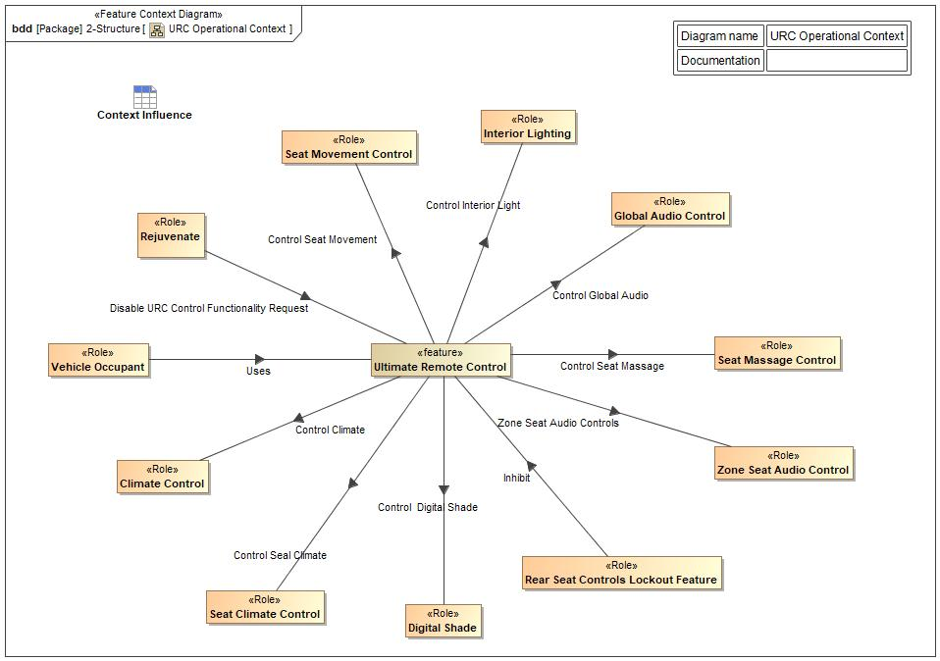

Figure 4: URC Operational Context

## List of Influences

|  |  |  |
| --- | --- | --- |
| **ID** | **External Entity** | **Influence Description** |
| Control Digital Shade | Ultimate Remote Control To Digital Shade | URC User modifies the Digital Shade from their zone |
| Control Climate | Ultimate Remote Control To Climate Control | URC User modifies the climate in their zone, URC Communicates with Climate control client and applies the change of settings to the zone |
| Control Global Audio | Ultimate Remote Control To Global Audio Control | URC User modifies the Global Audio settings from their zone |
| Control Interior Light | Ultimate Remote Control To Interior Lighting | URC User modifies interior light in their zone, URC Communicates with light function client and applies the change of settings to the zone |
| Control Seat Climate | Ultimate Remote Control To Seat Climate Control | URC User modifies the seat climate (heat/vent) in their zone |
| Control Seat Massage | Ultimate Remote Control To Seat Massage Control | URC User modifies the seating massage in their zone |
| Control Seat Movement | Ultimate Remote Control To Seat Movement Control | Control Seat movement |
| Disable URC Control Functionality Request | Rejuvenate  To Ultimate Remote Control | When in use Rejuvenate Feature status active disable URC control request |
| Rear Seat Control Lockout Feature | Rear Seat Controls Lockout Feature To Ultimate Remote Control | Request to Inhibit/disable URC |
| User | Vehicle Occupant To Ultimate Remote Control | URC User interfaces with URC HHD application and uses the feature to control the seating zone settings |
| Zone Seat Audio Controls | Ultimate Remote Control To Zone Seat Audio Control | URC User modifies the seat zone audio settings in their zone |

Table 9: List of Influences

# Feature Modeling

## Operation Modes and States

**#Classification:** Optional (Mandatory for Functional Safety)

**#Link:** [RE Wiki – State Charts](http://wiki.ford.com/display/RequirementsEngineering/State+Charts?src=contextnavpagetreemode)

**#Hint:** State Charts are a popular means to express feature behavior in terms of states and modes. An advantage of this state machine like approach is that consistency can be easily verified.

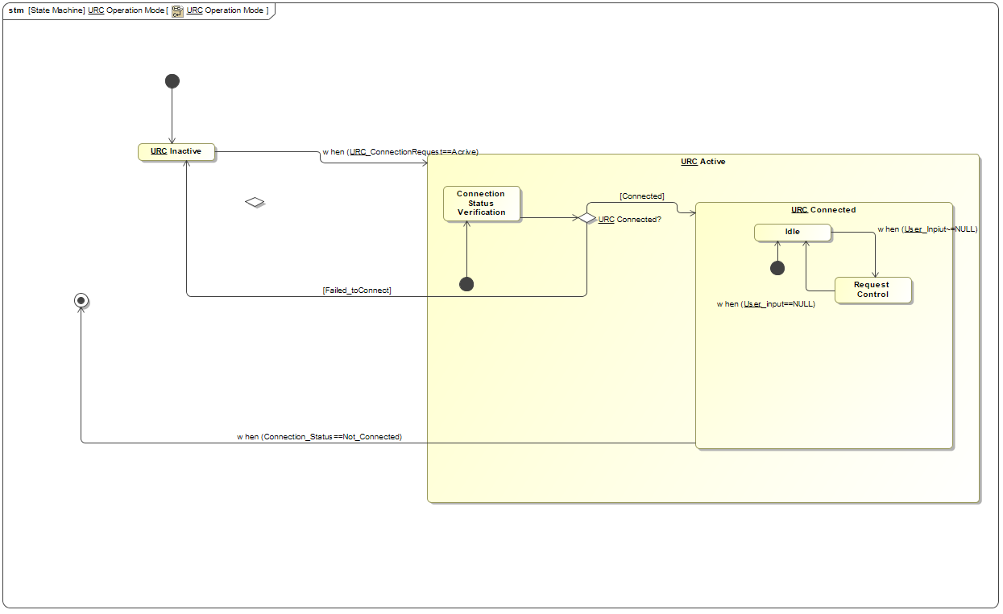

## Use Cases

**#Classification:** Optional

**#Link:** [RE Wiki – Use Cases](http://wiki.ford.com/display/RequirementsEngineering/Use+Cases+Overview?src=contextnavpagetreemodehttp://wiki.ford.com/display/RequirementsEngineering/Use+Cases?src=contextnavpagetreemode)

### Use Case Diagram

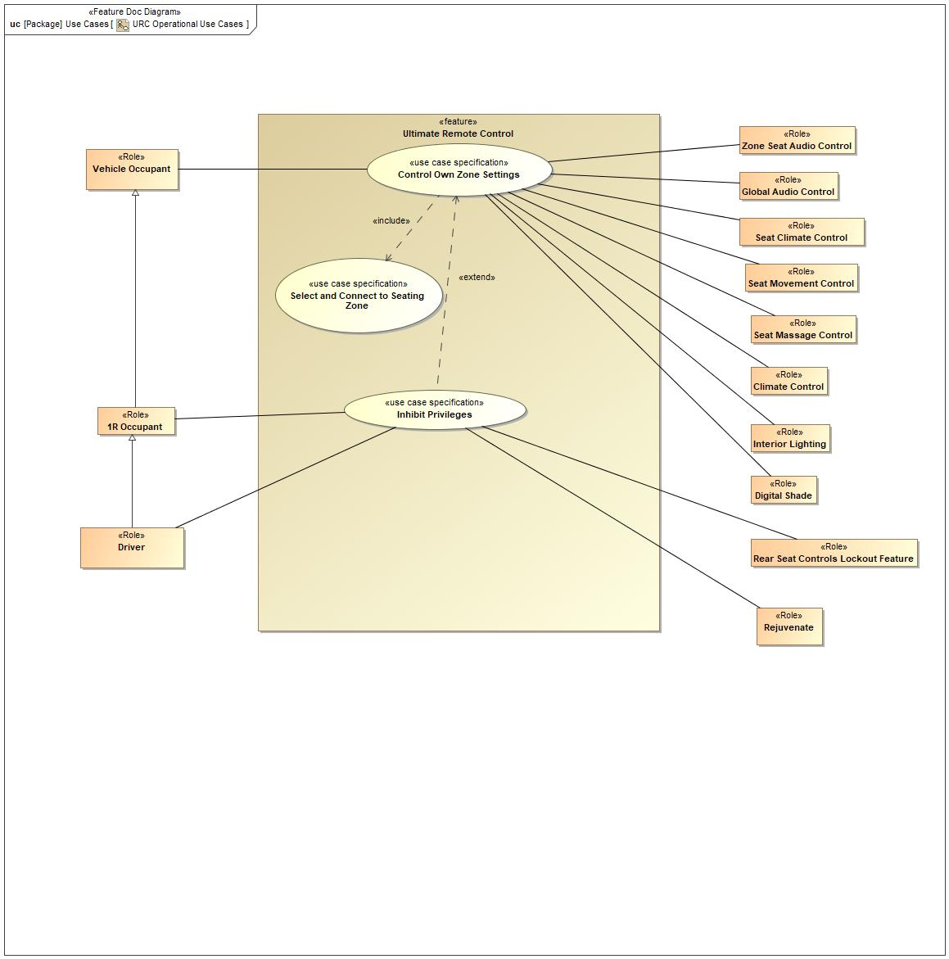

Figure 6: URC Operational Use Cases

### Actors

| **Actor** | **Description** |
| --- | --- |
| 1R Occupant | Occupant that is the first row passenger, sits next to the driver and can access the front HMI screen |
| Climate Control | Existing Climate Control system in the occupant zones |
| Digital Shade | Existing Digital Shade system that shades the sunroof |
| Driver | Entity responsible for driving the vehicle. The driver can manage control privileges, accept/decline requests from URC Users/Passengers to connect to vehicle |
| Global Audio Control | Existing global audio system in the vehicle |
| Interior Lighting | Existing interior lighting system in the occupant zones |
| Rear Seat Controls Lockout Feature | Lockout or inhibit URC user functionality |
| Rejuvenate Feature | Feature that provides a “Rejuvenate” experience for the driver when the vehicle is stationary – will disable URC when active |
| Seat Climate Control | Existing system that controls the seat heat/vent per seat if content is available |
| Seat Massage Control | Existing system that controls the seat massage per seat if content is available |
| Seat Movement Control | Existing system that controls the seat position movement per seat if content is available |
| Vehicle Occupant | Occupant that is sitting in the second or third row seating positions |
| Zone Seat Audio Control | Individual audio per seat though seat back or seat headrest speakers – this is also known as the My Seat Space feature |

Table 12: List of Actors

### Use Case Descriptions

**#Classification:** Optional

Control Own Zone Settings

|  |  |  |
| --- | --- | --- |
| **Actors** | Secondary | Climate Control |
| Secondary | Interior Lighting |
| Secondary | Seat Climate Control |
| Secondary | Seat Movement Control |
| Primary | 1R Occupant |
| Secondary | Digital Shade |
| Primary | Driver |
| Secondary | Global Audio Control |
| Secondary | Rear Seat Controls Lockout Feature |
| Secondary | Rejuvenate |
| Secondary | Seat Massage Control |
| Primary | Vehicle Occupant |
| Secondary | Zone Seat Audio Control |
| **Subject** |  | Ultimate Remote Control |
| **Description** |  | URC User requests to control functions within their seating zone (seat movement, lighting, climate, zone audio) on their HHD |
| **Preconditions** | PreC1 | URC Application is already downloaded to the user HHD |
| PreC2 | URC User is connected to vehicle and has a defined Seat ID (selected their seat during the connection process) |
| PreC3 | Vehicle must have URC feature |
| PreC4 | Vehicle must have rear content to control (example: seat functions, climate functions) |
| **Triggers** | T1 | User decides to use URC on HHD device |
| T2 | User selects control request on HHD |
| **Main Flow Description** |  | URC User requests to control functions within their seating zone (seat movement, lighting, climate, zone audio) on their HHD |
| **Main Flow** | M1 | User requests from the URC Feature to control settings in their seating zone on HHD |
| M2 | URC User requests Climate control |
| M3 | URC Feature provides Climate control status |
| M4 | URC User requests Seat Position control |
| M5 | URC Feature provides Seat Position status |
| M6 | URC User requests Seat Massage control |
| M7 | URC Feature provides Seat Massage status |
| M8 | URC User requests Seat Climate (Heat/Vent) control |
| M9 | URC Feature provides Seat Climate (Heat/Vent) status |
| M10 | URC User requests Interior Lighting control |
| M11 | URC Feature provides Interior Lighting status |
| M12 | URC User requestsl Global Audio control |
| M13 | URC Feature provides Global Audio control Status |
| M14 | URC User requests Zone Audio control |
| M15 | URC Feature provides Zone Audio Status |
| M16 | URC User requests Digital Shade control |
| M17 | URC Feature provides Digital Shade Status |
| M18 | URC User disconnects from vehicle |
| M19 | Occupant Leaves Seating Zone |
| **Postconditions** | PostC1 | URC User successfully updates seating zone settings and makes their seating zone comfortable |

Inhibit Privileges

|  |  |  |
| --- | --- | --- |
| **Actors** | Primary | Driver |
| Secondary | Rear Seat Controls Lockout Feature |
| Secondary | Rejuvenate |
| Primary | 1R Occupant |
|  | Primary | Vehicle Occupant |
| **Subject** |  | Ultimate Remote Control |
| **Description** |  | URC User's have certain controls disabled by RSCL or Rejuvenate Features |
| **Preconditions** | PreC1 | 2R 3R Users connected to URC |
| PreC2 | Driver has a need to lockout URC user |
| PreC3 | Driver has access to infotainment system screen |
| PreC4 | Rear Seat Controls Lockout Feature is present in infotainment system |
| PreC5 | Rejuvenate Feature included on vehicle (Rejuvenate Feature disables some controls of URC) |
| PreC6 | Vehicle is ON |
| **Triggers** | T1 | URC User's initiates distracting functionality to the driver |
| T2 | Driver needs to disable 2R or 3R URC User's |
| **Main Flow Description** |  | URC User's have certain controls disabled by RSCL or Rejuvenate Features |
| **Main Flow** | M1 | Driver selects Rear Seat Controls Lockout Menu in infotainment system |
| M2 | Driver selects 2R 3R function (Climate, Audio, All URC) to disable |
| M3 | 2R 3R URC User's HHD App controls are disabled |
| M4 | Rejuvenate Feature Status becomes active |
| M5 | URC User's HHD app functions that disrupt Rejuvenate experience is disabled |
| M6 | URC User are disabled until Rejuvenate status inactive or RSCL re-enables the controls |
| **Postconditions** | PostC1 | 2R 3R URC users blocked from using URC HHD app |

Select and Connect to Seating Zone

|  |  |  |
| --- | --- | --- |
| **Actors** | Primary | Vehicle Occupant |
|  | Secondary | Hand Held Device |
|  | Secondary | Vehicle/Infotainment System |
| **Subject** |  | Ultimate Remote Control |
| **Description** |  | URC User will request to connect to the vehicle and select the seat they are occupying |
| **Preconditions** | PreC1 | Infotainment system must be fully operational |
| PreC2 | URC App is already downloaded to the User's HHD |
| PreC3 | Vehicle must have URC Feature |
| PreC4 | Vehicle must have content to control |
| **Triggers** | T1 | User decides to use URC |
| T2 | User opens up URC HHD app and selects URC section |
| **Main Flow Description** |  | URC User will request to connect to the vehicle and select the seat they are occupying |
| **Main Flow** | M1 | User opens URC App on HHD |
| M2 | User selects URC/Passenger tile/section in application |
| M3 | Vehicle infotainment system advertises connection invitation |
| M4 | User is prompted in HHD App to select the seat they are occuping |
| M5 | User is prompted in HHD to select the infotainment system connection advertisement |
| M6 | Infotainment system receives seat location and connection request from User |
| M7 | Infotainment system checks permanent URC connection list to see if the User has connected previously to the vehicle |
| M8 | Driver accepts seat location and connection request on infotainment system |
| M9 | Pin is displayed on User's HHD device |
| M10 | Pin displayed on infotainment system screen |
| M11 | User compares pin and selects "Pair" if they match on the HHD |
| M12 | Driver classifes User as permanent (or temporary see alt flow 1) |
| M13 | Users phone ID is stored in URC Permanent Connection list in infotainment system |
| M14 | User recieves feedback connection was successful |
| M15 | Zone Database in Infotainment system sends status of available content to URC HHD |
| M16 | User lands on URC HHD Command Center control screen ready to control seating zone |
| **Alternative Flow Description** |  | This alt flow starts if the URC User is classified as temporary instead of permenant. Then the user is not added to the permanent connection list. |
| **Alternative Flow Steps** | A1 | Driver classifes User as temporary |
| A2 | Users phone ID is not stored (will be deleted after connection is severed) |
| A3 | User recieves feedback connection was successful |
| A4 | Zone Database in Infotainment system sends status of available content to URC HHD |
| A5 | User lands on URC HHD Command Center control screen ready to control seating zone |
| **Postconditions** | PostC1 | URC User is connected and ready to control their seating zone |

## Driving and Operation Scenarios

**#Classification:** Optional (Mandatory for Functional Safety)

**#Functional Safety:** Driving and operating scenarios which impact the functionality of the feature can be used to check, if the situation analysis in the HARA is complete

**#Link:** [RE Wiki – Driving Scenarios](http://wiki.ford.com/display/RequirementsEngineering/Driving+Scenarios?src=contextnavpagetreemode)

|  |  |  |
| --- | --- | --- |
| **Traffic & non-motorists** | **Description** | **URC Impact** |
| Driver in the vehicle | Includes: - Driver is in vehicle and able to intervene - Driver is asleep when vehicle is stationary  ISO 26262-3 Note: Assumption-driver is in appropriate condition to drive, has appropriate training, and is complying w/ legal regulations. | Driver needs to be inside the vehicle to approval URC User's connection requests in front HMI screen |
| Passenger(s) in vehicle | Includes: - Passengers on front seat - Passenger(s) on rear bench seat - Passenger but no driver available - Sleeping person(s) in the vehicle - Car used for transport of persons (variable number of seats) | Passengers need to be inside the vehicle to use URC Feature to control interior vehicle comfort systems |

## Decision Tables

**#Classification:** Optional

**#Link:** [RE Wiki – Decision Tables](http://wiki.ford.com/display/RequirementsEngineering/Decision+Table).

**#Hint:** Use decision table, if behavior is not state based (in that case prefer state chart from ch. 5.1) and based purely on current inputs.

*Not supported by MagicDraw report generation.*

# Feature Requirements

**#Functional Safety:** In general, safety requirements are not listed here. However, it is possible that later in the development process, a non-safety requirement becomes a safety requirement. In such a case it may remain on this list.

**#Link:** [RE Wiki – How to write good requirements](http://wiki.ford.com/display/RequirementsEngineering/How+to+write+better+requirements?src=contextnavpagetreemode).

## Functional Requirements

R_F_URC_001 Pin Compare

A temporary URC user must compare a numerical pin on the HHD display to the infotainment system screen and verify they match

|  |  |  |  |  |  |  |  |
| --- | --- | --- | --- | --- | --- | --- | --- |
| Requirement ID: R_F_URC_001 | | | | | | | |
| **Rationale** | Verify user is connecting to the correct vehicle on initial connection | | | | | | |
| **Acceptance Criteria** |  | | | | | | |
| **Notes** |  | | | | | | |
| **Source** |  | | | | | **Owner** |  |
| **Source Req.** |  | | | | | **V&V Method** |  |
| **Type** |  | | | **Priority** |  | **Status** |  |
| [Req. Template](http://wiki.ford.com/display/RequirementsEngineering/Requirements+Attributes) Version | | 6.0 | End of Requirement | | | | |

R_F_URC_002 Status Feedback

The URC feature shall provide status to the user on the commodities they are controlling and if a URC HHD app request was successful

|  |  |  |  |  |  |  |  |
| --- | --- | --- | --- | --- | --- | --- | --- |
| Requirement ID: R_F_URC_002 | | | | | | | |
| **Rationale** | User needs to know the commodity successfully updated and the HHD HMI represents the correct current setting. (Says the correct temperature) | | | | | | |
| **Acceptance Criteria** |  | | | | | | |
| **Notes** |  | | | | | | |
| **Source** |  | | | | | **Owner** |  |
| **Source Req.** |  | | | | | **V&V Method** |  |
| **Type** |  | | | **Priority** |  | **Status** |  |
| [Req. Template](http://wiki.ford.com/display/RequirementsEngineering/Requirements+Attributes) Version | | 6.0 | End of Requirement | | | | |

R_F_URC_003 Seating Climate (Heat/Vent) Control

The URC feature shall allow user to control their own seat climate functions (seat heat/vent)

|  |  |  |  |  |  |  |  |
| --- | --- | --- | --- | --- | --- | --- | --- |
| Requirement ID: R_F_URC_003 | | | | | | | |
| **Rationale** | Customer want to control seat heat/vent from URC HHD App | | | | | | |
| **Acceptance Criteria** |  | | | | | | |
| **Notes** |  | | | | | | |
| **Source** |  | | | | | **Owner** |  |
| **Source Req.** |  | | | | | **V&V Method** |  |
| **Type** |  | | | **Priority** |  | **Status** |  |
| [Req. Template](http://wiki.ford.com/display/RequirementsEngineering/Requirements+Attributes) Version | | 6.0 | End of Requirement | | | | |

R_F_URC_004 Drive Response To Classification - Condition

If driver does not respond to a temporary or permanent prompt, default to temporary after 60 seconds

|  |  |  |  |  |  |  |  |
| --- | --- | --- | --- | --- | --- | --- | --- |
| Requirement ID: R_F_URC_004 | | | | | | | |
| **Rationale** | A user should not be made permanent by default | | | | | | |
| **Acceptance Criteria** |  | | | | | | |
| **Notes** |  | | | | | | |
| **Source** |  | | | | | **Owner** |  |
| **Source Req.** |  | | | | | **V&V Method** |  |
| **Type** |  | | | **Priority** |  | **Status** |  |
| [Req. Template](http://wiki.ford.com/display/RequirementsEngineering/Requirements+Attributes) Version | | 6.0 | End of Requirement | | | | |

R_F_URC_005 Zone Connection

URC User Interface device shall connect with a seating zone prior to using the feature

|  |  |  |  |  |  |  |  |
| --- | --- | --- | --- | --- | --- | --- | --- |
| Requirement ID: R_F_URC_005 | | | | | | | |
| **Rationale** | URC HHD must be connected to a seating zone to control the content | | | | | | |
| **Acceptance Criteria** |  | | | | | | |
| **Notes** |  | | | | | | |
| **Source** |  | | | | | **Owner** |  |
| **Source Req.** |  | | | | | **V&V Method** |  |
| **Type** |  | | | **Priority** |  | **Status** |  |
| [Req. Template](http://wiki.ford.com/display/RequirementsEngineering/Requirements+Attributes) Version | | 6.0 | End of Requirement | | | | |

R_F_URC_006 Driver Disconnection

The URC feature shall allow the Driver to initiate the disconnection of each individual user from front HMI screen

|  |  |  |  |  |  |  |  |
| --- | --- | --- | --- | --- | --- | --- | --- |
| Requirement ID: R_F_URC_006 | | | | | | | |
| **Rationale** | Driver needs to have a quick way to disconnect a user incase a user selects the wrong seating zone | | | | | | |
| **Acceptance Criteria** |  | | | | | | |
| **Notes** |  | | | | | | |
| **Source** |  | | | | | **Owner** |  |
| **Source Req.** |  | | | | | **V&V Method** |  |
| **Type** |  | | | **Priority** |  | **Status** |  |
| [Req. Template](http://wiki.ford.com/display/RequirementsEngineering/Requirements+Attributes) Version | | 6.0 | End of Requirement | | | | |

R_F_URC_008 URC Disable

URC Feature shall be disabled when the infotainment system is off

|  |  |  |  |  |  |  |  |
| --- | --- | --- | --- | --- | --- | --- | --- |
| Requirement ID: R_F_URC_008 | | | | | | | |
| **Rationale** | URC not functional with the infotainment system shut down | | | | | | |
| **Acceptance Criteria** |  | | | | | | |
| **Notes** |  | | | | | | |
| **Source** |  | | | | | **Owner** |  |
| **Source Req.** |  | | | | | **V&V Method** |  |
| **Type** |  | | | **Priority** |  | **Status** |  |
| [Req. Template](http://wiki.ford.com/display/RequirementsEngineering/Requirements+Attributes) Version | | 6.0 | End of Requirement | | | | |

R_F_URC_009 Drive Response To Connect - Condition

If driver does not respond to a accept/decline connection prompt, URC shall default to decline after 60 seconds

|  |  |  |  |  |  |  |  |
| --- | --- | --- | --- | --- | --- | --- | --- |
| Requirement ID: R_F_URC_009 | | | | | | | |
| **Rationale** | A user should not be connected by default hence decline | | | | | | |
| **Acceptance Criteria** |  | | | | | | |
| **Notes** |  | | | | | | |
| **Source** |  | | | | | **Owner** |  |
| **Source Req.** |  | | | | | **V&V Method** |  |
| **Type** |  | | | **Priority** |  | **Status** |  |
| [Req. Template](http://wiki.ford.com/display/RequirementsEngineering/Requirements+Attributes) Version | | 6.0 | End of Requirement | | | | |

R_F_URC_0011 HHD Device Connection

A URC user shall be able to connect to the vehicle through the URC HHD app when the HHD is inside the vehicle

|  |  |  |  |  |  |  |  |
| --- | --- | --- | --- | --- | --- | --- | --- |
| Requirement ID: R_F_URC_0011 | | | | | | | |
| **Rationale** | URC controls interior content, there is no need to connect when the user is outside the vehicle | | | | | | |
| **Acceptance Criteria** |  | | | | | | |
| **Notes** |  | | | | | | |
| **Source** |  | | | | | **Owner** |  |
| **Source Req.** |  | | | | | **V&V Method** |  |
| **Type** |  | | | **Priority** |  | **Status** |  |
| [Req. Template](http://wiki.ford.com/display/RequirementsEngineering/Requirements+Attributes) Version | | 6.0 | End of Requirement | | | | |

R_F_URC_0012 User Disconnection

The URC feature shall allow the user to disconnect their HHD from connection the vehicle

|  |  |  |  |  |  |  |  |
| --- | --- | --- | --- | --- | --- | --- | --- |
| Requirement ID: R_F_URC_0012 | | | | | | | |
| **Rationale** | Customer want to allow disconnect by choice | | | | | | |
| **Acceptance Criteria** |  | | | | | | |
| **Notes** |  | | | | | | |
| **Source** |  | | | | | **Owner** |  |
| **Source Req.** |  | | | | | **V&V Method** |  |
| **Type** |  | | | **Priority** |  | **Status** |  |
| [Req. Template](http://wiki.ford.com/display/RequirementsEngineering/Requirements+Attributes) Version | | 6.0 | End of Requirement | | | | |

R_F_URC_0014 Search URC Connected ID Classification

When a URC user is connecting, the infotainment system will search the permanent connection list and compare the User's HHD ID

|  |  |  |  |  |  |  |  |
| --- | --- | --- | --- | --- | --- | --- | --- |
| Requirement ID: R_F_URC_0014 | | | | | | | |
| **Rationale** | This makes the connection process simipler for a permanent user | | | | | | |
| **Acceptance Criteria** |  | | | | | | |
| **Notes** |  | | | | | | |
| **Source** |  | | | | | **Owner** |  |
| **Source Req.** |  | | | | | **V&V Method** |  |
| **Type** |  | | | **Priority** |  | **Status** |  |
| [Req. Template](http://wiki.ford.com/display/RequirementsEngineering/Requirements+Attributes) Version | | 6.0 | End of Requirement | | | | |

R_F_URC_0015 Zone Audio Control

URC shall provide all passengers with the ability to control their own sound/audio features independently from other passenger areas in the vehicle when MSS is present in the vehicle

|  |  |  |  |  |  |  |  |
| --- | --- | --- | --- | --- | --- | --- | --- |
| Requirement ID: R_F_URC_0015 | | | | | | | |
| **Rationale** | MSS needs an HMI (URC) to control music functions like Volume, share, do not disturb, etc. | | | | | | |
| **Acceptance Criteria** |  | | | | | | |
| **Notes** |  | | | | | | |
| **Source** |  | | | | | **Owner** |  |
| **Source Req.** |  | | | | | **V&V Method** |  |
| **Type** |  | | | **Priority** |  | **Status** |  |
| [Req. Template](http://wiki.ford.com/display/RequirementsEngineering/Requirements+Attributes) Version | | 6.0 | End of Requirement | | | | |

R_F_URC_0016 URC Enable

URC Feature shall be enabled when the infotainment system is fully active (HMI Status = ON)

|  |  |  |  |  |  |  |  |
| --- | --- | --- | --- | --- | --- | --- | --- |
| Requirement ID: R_F_URC_0016 | | | | | | | |
| **Rationale** | URC can utilize the Front HMI screen functionality | | | | | | |
| **Acceptance Criteria** |  | | | | | | |
| **Notes** |  | | | | | | |
| **Source** |  | | | | | **Owner** |  |
| **Source Req.** |  | | | | | **V&V Method** |  |
| **Type** |  | | | **Priority** |  | **Status** |  |
| [Req. Template](http://wiki.ford.com/display/RequirementsEngineering/Requirements+Attributes) Version | | 6.0 | End of Requirement | | | | |

R_F_URC_0019 Stationary Driver Use

The Driver may use URC on their mobile device when the vehicle is in park

|  |  |  |  |  |  |  |  |
| --- | --- | --- | --- | --- | --- | --- | --- |
| Requirement ID: R_F_URC_0019 | | | | | | | |
| **Rationale** | Ensure Driver is not distracted when the vehicle is in motion | | | | | | |
| **Acceptance Criteria** |  | | | | | | |
| **Notes** | Driver URC mobile device use is program specific*  MY24 CDX747/746 is not implementing driver URC HHD controls | | | | | | |
| **Source** |  | | | | | **Owner** |  |
| **Source Req.** |  | | | | | **V&V Method** |  |
| **Type** |  | | | **Priority** |  | **Status** |  |
| [Req. Template](http://wiki.ford.com/display/RequirementsEngineering/Requirements+Attributes) Version | | 6.0 | End of Requirement | | | | |

R_F_URC_0021 Seating Position Control

URC feature shall allow user to control their own seating position functions

|  |  |  |  |  |  |  |  |
| --- | --- | --- | --- | --- | --- | --- | --- |
| Requirement ID: R_F_URC_0021 | | | | | | | |
| **Rationale** | User convenience | | | | | | |
| **Acceptance Criteria** |  | | | | | | |
| **Notes** |  | | | | | | |
| **Source** |  | | | | | **Owner** |  |
| **Source Req.** |  | | | | | **V&V Method** |  |
| **Type** |  | | | **Priority** |  | **Status** |  |
| [Req. Template](http://wiki.ford.com/display/RequirementsEngineering/Requirements+Attributes) Version | | 6.0 | End of Requirement | | | | |

R_F_URC_0022 Global Audio Control

URC feature shall allow user the ability to share a source from their HHD to the global audio of the vehicle when you do not have MSS

|  |  |  |  |  |  |  |  |
| --- | --- | --- | --- | --- | --- | --- | --- |
| Requirement ID: R_F_URC_0022 | | | | | | | |
| **Rationale** | User convenience | | | | | | |
| **Acceptance Criteria** |  | | | | | | |
| **Notes** |  | | | | | | |
| **Source** |  | | | | | **Owner** |  |
| **Source Req.** |  | | | | | **V&V Method** |  |
| **Type** |  | | | **Priority** |  | **Status** |  |
| [Req. Template](http://wiki.ford.com/display/RequirementsEngineering/Requirements+Attributes) Version | | 6.0 | End of Requirement | | | | |

R_F_URC_0023 Digital Shade Control

The URC Feature shall provide the user with the ability to control the digital shade by zone

|  |  |  |  |  |  |  |  |
| --- | --- | --- | --- | --- | --- | --- | --- |
| Requirement ID: R_F_URC_0023 | | | | | | | |
| **Rationale** | Customer want to control the ditigal shade area above their seating zone | | | | | | |
| **Acceptance Criteria** |  | | | | | | |
| **Notes** |  | | | | | | |
| **Source** |  | | | | | **Owner** |  |
| **Source Req.** |  | | | | | **V&V Method** |  |
| **Type** |  | | | **Priority** |  | **Status** |  |
| [Req. Template](http://wiki.ford.com/display/RequirementsEngineering/Requirements+Attributes) Version | | 6.0 | End of Requirement | | | | |

R_F_URC_0024 Rear Seat Controls Lockout -Inhibit

The URC feature shall be incorporated with the Rear Seat Controls Lockout Feature to enable the driver to disable the 2R/3R Users of the URC feature

|  |  |  |  |  |  |  |  |
| --- | --- | --- | --- | --- | --- | --- | --- |
| Requirement ID: R_F_URC_0024 | | | | | | | |
| **Rationale** | Driver can inhibit URC users if they mis-use URC | | | | | | |
| **Acceptance Criteria** |  | | | | | | |
| **Notes** |  | | | | | | |
| **Source** |  | | | | | **Owner** |  |
| **Source Req.** |  | | | | | **V&V Method** |  |
| **Type** |  | | | **Priority** |  | **Status** |  |
| [Req. Template](http://wiki.ford.com/display/RequirementsEngineering/Requirements+Attributes) Version | | 6.0 | End of Requirement | | | | |

R_F_URC_0026 Connection Advertisement

URC HHD app shall be able to communicate with the infotainment system connection/advertisement availability list

|  |  |  |  |  |  |  |  |
| --- | --- | --- | --- | --- | --- | --- | --- |
| Requirement ID: R_F_URC_0026 | | | | | | | |
| **Rationale** | Store a list of permanent URC Users | | | | | | |
| **Acceptance Criteria** |  | | | | | | |
| **Notes** |  | | | | | | |
| **Source** |  | | | | | **Owner** |  |
| **Source Req.** |  | | | | | **V&V Method** |  |
| **Type** |  | | | **Priority** |  | **Status** |  |
| [Req. Template](http://wiki.ford.com/display/RequirementsEngineering/Requirements+Attributes) Version | | 6.0 | End of Requirement | | | | |

R_F_URC_0027 Lighting Control

URC feature shall allow passengers the ability to control their own lighting if the lighting is independent by seating zone

|  |  |  |  |  |  |  |  |
| --- | --- | --- | --- | --- | --- | --- | --- |
| Requirement ID: R_F_URC_0027 | | | | | | | |
| **Rationale** | User convenience | | | | | | |
| **Acceptance Criteria** |  | | | | | | |
| **Notes** | MY24 CDX747/746 is not implementing URC interior lighting controls | | | | | | |
| **Source** |  | | | | | **Owner** |  |
| **Source Req.** |  | | | | | **V&V Method** |  |
| **Type** |  | | | **Priority** |  | **Status** |  |
| [Req. Template](http://wiki.ford.com/display/RequirementsEngineering/Requirements+Attributes) Version | | 6.0 | End of Requirement | | | | |

R_F_URC_0030 Rear Seat Controls Lockout - Climate

The URC feature shall disable the rear climate control when the rear climate control is disabled by RSCL feature

|  |  |  |  |  |  |  |  |
| --- | --- | --- | --- | --- | --- | --- | --- |
| Requirement ID: R_F_URC_0030 | | | | | | | |
| **Rationale** | Aligns with the RSCL climate disable use case | | | | | | |
| **Acceptance Criteria** |  | | | | | | |
| **Notes** |  | | | | | | |
| **Source** |  | | | | | **Owner** |  |
| **Source Req.** |  | | | | | **V&V Method** |  |
| **Type** |  | | | **Priority** |  | **Status** |  |
| [Req. Template](http://wiki.ford.com/display/RequirementsEngineering/Requirements+Attributes) Version | | 6.0 | End of Requirement | | | | |

R_F_URC_0032 User Recognition

The URC feature shall give the driver the ability to classify the user's connection as temporary or permanent

|  |  |  |  |  |  |  |  |
| --- | --- | --- | --- | --- | --- | --- | --- |
| Requirement ID: R_F_URC_0032 | | | | | | | |
| **Rationale** | Supports two use cases – ride share and family vehicle | | | | | | |
| **Acceptance Criteria** |  | | | | | | |
| **Notes** |  | | | | | | |
| **Source** |  | | | | | **Owner** |  |
| **Source Req.** |  | | | | | **V&V Method** |  |
| **Type** |  | | | **Priority** |  | **Status** |  |
| [Req. Template](http://wiki.ford.com/display/RequirementsEngineering/Requirements+Attributes) Version | | 6.0 | End of Requirement | | | | |

R_F_URC_0033 Zone Functions recognition

The URC shall be able to distinguish between the different zone functions availability (third row seat has less functionality to control than first and second row seats)

|  |  |  |  |  |  |  |  |
| --- | --- | --- | --- | --- | --- | --- | --- |
| Requirement ID: R_F_URC_0033 | | | | | | | |
| **Rationale** | Populate the URC Users HHD HMI with the proper controls relating to that specific zone | | | | | | |
| **Acceptance Criteria** |  | | | | | | |
| **Notes** |  | | | | | | |
| **Source** |  | | | | | **Owner** |  |
| **Source Req.** |  | | | | | **V&V Method** |  |
| **Type** |  | | | **Priority** |  | **Status** |  |
| [Req. Template](http://wiki.ford.com/display/RequirementsEngineering/Requirements+Attributes) Version | | 6.0 | End of Requirement | | | | |

R_F_URC_0034 Initiate Connection

URC app on a user's HHD shall prompt a seat selection and pairing list to the Infotainment (HMI) system

|  |  |  |  |  |  |  |  |
| --- | --- | --- | --- | --- | --- | --- | --- |
| Requirement ID: R_F_URC_0034 | | | | | | | |
| **Rationale** | For a seamless connection process to the vehicle | | | | | | |
| **Acceptance Criteria** |  | | | | | | |
| **Notes** |  | | | | | | |
| **Source** |  | | | | | **Owner** |  |
| **Source Req.** |  | | | | | **V&V Method** |  |
| **Type** |  | | | **Priority** |  | **Status** |  |
| [Req. Template](http://wiki.ford.com/display/RequirementsEngineering/Requirements+Attributes) Version | | 6.0 | End of Requirement | | | | |

R_F_URC_0035 Driver Approval Condition

If the infotainment system recognizes the URC User's HHD ID as permanent, upon connection process they do not need driver approval

|  |  |  |  |  |  |  |  |
| --- | --- | --- | --- | --- | --- | --- | --- |
| Requirement ID: R_F_URC_0035 | | | | | | | |
| **Rationale** | This makes the connection process simipler for a permanent user | | | | | | |
| **Acceptance Criteria** |  | | | | | | |
| **Notes** |  | | | | | | |
| **Source** |  | | | | | **Owner** |  |
| **Source Req.** |  | | | | | **V&V Method** |  |
| **Type** |  | | | **Priority** |  | **Status** |  |
| [Req. Template](http://wiki.ford.com/display/RequirementsEngineering/Requirements+Attributes) Version | | 6.0 | End of Requirement | | | | |

R_F_URC_0037 Receive Zone Database

The infotainment system shall use a zone database to communicate with the URC HHD app, which populates what content and status is available to control per seating zone (URC Status function)

|  |  |  |  |  |  |  |  |
| --- | --- | --- | --- | --- | --- | --- | --- |
| Requirement ID: R_F_URC_0037 | | | | | | | |
| **Rationale** | Populate the URC Users HHD HMI with the proper controls relating to that specific zone | | | | | | |
| **Acceptance Criteria** |  | | | | | | |
| **Notes** |  | | | | | | |
| **Source** |  | | | | | **Owner** |  |
| **Source Req.** |  | | | | | **V&V Method** |  |
| **Type** |  | | | **Priority** |  | **Status** |  |
| [Req. Template](http://wiki.ford.com/display/RequirementsEngineering/Requirements+Attributes) Version | | 6.0 | End of Requirement | | | | |

R_F_URC_0038 Seating Massage Control

URC feature shall allow user to control their own seat massage functions

|  |  |  |  |  |  |  |  |
| --- | --- | --- | --- | --- | --- | --- | --- |
| Requirement ID: R_F_URC_0038 | | | | | | | |
| **Rationale** | User convenience | | | | | | |
| **Acceptance Criteria** |  | | | | | | |
| **Notes** |  | | | | | | |
| **Source** |  | | | | | **Owner** |  |
| **Source Req.** |  | | | | | **V&V Method** |  |
| **Type** |  | | | **Priority** |  | **Status** |  |
| [Req. Template](http://wiki.ford.com/display/RequirementsEngineering/Requirements+Attributes) Version | | 6.0 | End of Requirement | | | | |

R_F_URC_0039 Advertisement Initiation -Motion

When the vehicle is in motion, the connection advertisement needs to be initiated by a button press (cannot automatically advertise when vehicle in motion)

|  |  |  |  |  |  |  |  |
| --- | --- | --- | --- | --- | --- | --- | --- |
| Requirement ID: R_F_URC_0039 | | | | | | | |
| **Rationale** | Security/Bluetooth requirement | | | | | | |
| **Acceptance Criteria** |  | | | | | | |
| **Notes** |  | | | | | | |
| **Source** |  | | | | | **Owner** |  |
| **Source Req.** |  | | | | | **V&V Method** |  |
| **Type** |  | | | **Priority** |  | **Status** |  |
| [Req. Template](http://wiki.ford.com/display/RequirementsEngineering/Requirements+Attributes) Version | | 6.0 | End of Requirement | | | | |

R_F_URC_0041 Rejuvenate Driver URC Control Impact

When the Rejuvenate feature is active, URC feature shall allow the driver to only control seat functions and climate (Disable audio, lighting, and digital shade controls in URC HHD app)

|  |  |  |  |  |  |  |  |
| --- | --- | --- | --- | --- | --- | --- | --- |
| Requirement ID: R_F_URC_0041 | | | | | | | |
| **Rationale** | This allows the driver some functionality on URC however it does not take away from the Rejuvenate experience | | | | | | |
| **Acceptance Criteria** |  | | | | | | |
| **Notes** |  | | | | | | |
| **Source** |  | | | | | **Owner** |  |
| **Source Req.** |  | | | | | **V&V Method** |  |
| **Type** |  | | | **Priority** |  | **Status** |  |
| [Req. Template](http://wiki.ford.com/display/RequirementsEngineering/Requirements+Attributes) Version | | 6.0 | End of Requirement | | | | |

R_F_URC_0042 Rejuvenate Passenger URC Control Impact

When the Rejuvenate feature is active, URC feature shall allow the passengers to only control seat functions (Disable climate, audio, lighting, and digital shade controls in URC HHD app)

|  |  |  |  |  |  |  |  |
| --- | --- | --- | --- | --- | --- | --- | --- |
| Requirement ID: R_F_URC_0042 | | | | | | | |
| **Rationale** | This allows the passengers some functionality on URC, but makes sure it does not disturb the driver’s Rejuvenate experience | | | | | | |
| **Acceptance Criteria** |  | | | | | | |
| **Notes** |  | | | | | | |
| **Source** |  | | | | | **Owner** |  |
| **Source Req.** |  | | | | | **V&V Method** |  |
| **Type** |  | | | **Priority** |  | **Status** |  |
| [Req. Template](http://wiki.ford.com/display/RequirementsEngineering/Requirements+Attributes) Version | | 6.0 | End of Requirement | | | | |

R_F_URC_0043 Driver Seat Connect -Check

When a URC user is trying to connect and control the driver seat, two checks shall happen. 1. That the vehicle is in park. 2. The User HHD ID must match the Primary Phone ID (Driver) stored in the Infotainment System (This connects over Classic BT)

|  |  |  |  |  |  |  |  |
| --- | --- | --- | --- | --- | --- | --- | --- |
| Requirement ID: R_F_URC_0043 | | | | | | | |
| **Rationale** | Verifies no user can control the driver seat that is not the driver | | | | | | |
| **Acceptance Criteria** |  | | | | | | |
| **Notes** | Driver URC mobile device use is program specific*  MY24 CDX747/746 is not implementing driver URC HHD controls | | | | | | |
| **Source** |  | | | | | **Owner** |  |
| **Source Req.** |  | | | | | **V&V Method** |  |
| **Type** |  | | | **Priority** |  | **Status** |  |
| [Req. Template](http://wiki.ford.com/display/RequirementsEngineering/Requirements+Attributes) Version | | 6.0 | End of Requirement | | | | |

R_F_URC_0044 Rear Seat Controls Lockout - Audio

The URC feature shall disable the audio control when the rear audio control is disabled by RSCL feature

|  |  |  |  |  |  |  |  |
| --- | --- | --- | --- | --- | --- | --- | --- |
| Requirement ID: R_F_URC_0044 | | | | | | | |
| **Rationale** | Aligns with the RSCL audio disable use case | | | | | | |
| **Acceptance Criteria** |  | | | | | | |
| **Notes** |  | | | | | | |
| **Source** |  | | | | | **Owner** |  |
| **Source Req.** |  | | | | | **V&V Method** |  |
| **Type** |  | | | **Priority** |  | **Status** |  |
| [Req. Template](http://wiki.ford.com/display/RequirementsEngineering/Requirements+Attributes) Version | | 6.0 | End of Requirement | | | | |

R_F_URC_0045 Independent Climate Control

URC shall provide all passengers with the ability to control their own climate independently from other passenger areas in the vehicle based on the definition of Quad Climate Zones

|  |  |  |  |  |  |  |  |
| --- | --- | --- | --- | --- | --- | --- | --- |
| Requirement ID: R_F_URC_0045 | | | | | | | |
| **Rationale** | Climate is a main function a user wants control of with hand held device | | | | | | |
| **Acceptance Criteria** |  | | | | | | |
| **Notes** |  | | | | | | |
| **Source** |  | | | | | **Owner** |  |
| **Source Req.** |  | | | | | **V&V Method** |  |
| **Type** |  | | | **Priority** |  | **Status** |  |
| [Req. Template](http://wiki.ford.com/display/RequirementsEngineering/Requirements+Attributes) Version | | 6.0 | End of Requirement | | | | |

R_F_URC_0046 Request Pathway

Infotainment system shall receive commands from each URC User, transfer them to signal/messages, and guide them to the proper seating zone

|  |  |  |  |  |  |  |  |
| --- | --- | --- | --- | --- | --- | --- | --- |
| Requirement ID: R_F_URC_0046 | | | | | | | |
| **Rationale** | So the proper request gets to the proper zone | | | | | | |
| **Acceptance Criteria** |  | | | | | | |
| **Notes** |  | | | | | | |
| **Source** |  | | | | | **Owner** |  |
| **Source Req.** |  | | | | | **V&V Method** |  |
| **Type** |  | | | **Priority** |  | **Status** |  |
| [Req. Template](http://wiki.ford.com/display/RequirementsEngineering/Requirements+Attributes) Version | | 6.0 | End of Requirement | | | | |

R_F_URC_0048 Advertisement Initiation - No Motion

When the vehicle is in not in motion, the connection advertisement can be automatically in process

|  |  |  |  |  |  |  |  |
| --- | --- | --- | --- | --- | --- | --- | --- |
| Requirement ID: R_F_URC_0048 | | | | | | | |
| **Rationale** | Security/Bluetooth requirement | | | | | | |
| **Acceptance Criteria** |  | | | | | | |
| **Notes** |  | | | | | | |
| **Source** |  | | | | | **Owner** |  |
| **Source Req.** |  | | | | | **V&V Method** |  |
| **Type** |  | | | **Priority** |  | **Status** |  |
| [Req. Template](http://wiki.ford.com/display/RequirementsEngineering/Requirements+Attributes) Version | | 6.0 | End of Requirement | | | | |

R_F_URC_0049 Zone Audio Sharing

The URC shall be able to initiate audio sharing across audio zones in the vehicle

|  |  |  |  |  |  |  |  |
| --- | --- | --- | --- | --- | --- | --- | --- |
| Requirement ID: R_F_URC_0049 | | | | | | | |
| **Rationale** | User convenience | | | | | | |
| **Acceptance Criteria** |  | | | | | | |
| **Notes** |  | | | | | | |
| **Source** |  | | | | | **Owner** |  |
| **Source Req.** |  | | | | | **V&V Method** |  |
| **Type** |  | | | **Priority** |  | **Status** |  |
| [Req. Template](http://wiki.ford.com/display/RequirementsEngineering/Requirements+Attributes) Version | | 6.0 | End of Requirement | | | | |

### Error Handling

No Error Handling Requirements specified.

## Non-Functional Requirements

***#Hint:*** *Non-functional requirements specify some performance criteria in addition to the functional behavior given defined by the functional requirements. Timing (if not already included in the functional requirements), security details (e.g. how secure does an algorithm have to be) reliability (e.g. mean time between failure) or maintainability could be specified in this section.*

### Safety

**#Hint:** Only those safety requirements, which are not related to Functional Safety (ISO26262) should go here. For Functional Safety refer to chapter 7 “Functional Safety”.

*Not supported by MagicDraw report generation.*

### Security

No Security Requirements specified.

### Reliability

No Reliability Requirements specified.

## HMI Requirements

**#Hint:** Requirements in this section could specify details of e.g. the icons, the GUI or the sounds.

R_F_URC_0017 Number of User Devices

Infotainment system shall accommodate connecting up to 6 URC users to the vehicle at one time

|  |  |  |  |  |  |  |  |
| --- | --- | --- | --- | --- | --- | --- | --- |
| Requirement ID: R_F_URC_0017 | | | | | | | |
| **Rationale** | HMI Menu needed to show who is connected inside the vehicle up to 6 people | | | | | | |
| **Acceptance Criteria** |  | | | | | | |
| **Notes** |  | | | | | | |
| **Source** |  | | | | | **Owner** |  |
| **Source Req.** |  | | | | | **V&V Method** |  |
| **Type** |  | | | **Priority** |  | **Status** |  |
| [Req. Template](http://wiki.ford.com/display/RequirementsEngineering/Requirements+Attributes) Version | | 6.0 | End of Requirement | | | | |

R_F_URC_0020 Driver Response

The Driver shall be able to accept/decline the connection request and seat location of the URC user using the infotainment system/ HMI

|  |  |  |  |  |  |  |  |
| --- | --- | --- | --- | --- | --- | --- | --- |
| Requirement ID: R_F_URC_0020 | | | | | | | |
| **Rationale** | Driver has full authority over the URC connections | | | | | | |
| **Acceptance Criteria** |  | | | | | | |
| **Notes** |  | | | | | | |
| **Source** |  | | | | | **Owner** |  |
| **Source Req.** |  | | | | | **V&V Method** |  |
| **Type** |  | | | **Priority** |  | **Status** |  |
| [Req. Template](http://wiki.ford.com/display/RequirementsEngineering/Requirements+Attributes) Version | | 6.0 | End of Requirement | | | | |

R_F_URC_0025 URC Zone Display

Infotainment system shall house a URC HMI screen that displays the seating zones and which HHDs are populated in each zone

|  |  |  |  |  |  |  |  |
| --- | --- | --- | --- | --- | --- | --- | --- |
| Requirement ID: R_F_URC_0025 | | | | | | | |
| **Rationale** | Allow driver to recoginize user location | | | | | | |
| **Acceptance Criteria** |  | | | | | | |
| **Notes** |  | | | | | | |
| **Source** |  | | | | | **Owner** |  |
| **Source Req.** |  | | | | | **V&V Method** |  |
| **Type** |  | | | **Priority** |  | **Status** |  |
| [Req. Template](http://wiki.ford.com/display/RequirementsEngineering/Requirements+Attributes) Version | | 6.0 | End of Requirement | | | | |

R_F_URC_0028 Zone Seating Layout

URC shall be able to display the zone seating layout on both infotainment system and URC User's HHD HMI device

|  |  |  |  |  |  |  |  |
| --- | --- | --- | --- | --- | --- | --- | --- |
| Requirement ID: R_F_URC_0028 | | | | | | | |
| **Rationale** | To synchronize the display on both URC HHD app and Front HMI | | | | | | |
| **Acceptance Criteria** |  | | | | | | |
| **Notes** |  | | | | | | |
| **Source** |  | | | | | **Owner** |  |
| **Source Req.** |  | | | | | **V&V Method** |  |
| **Type** |  | | | **Priority** |  | **Status** |  |
| [Req. Template](http://wiki.ford.com/display/RequirementsEngineering/Requirements+Attributes) Version | | 6.0 | End of Requirement | | | | |

R_F_URC_0029 Selection - HMI

URC feature shall recognize each URC User selection seat and display it on infotainment system screen

|  |  |  |  |  |  |  |  |
| --- | --- | --- | --- | --- | --- | --- | --- |
| Requirement ID: R_F_URC_0029 | | | | | | | |
| **Rationale** | URC seat selection placement in front HMI | | | | | | |
| **Acceptance Criteria** |  | | | | | | |
| **Notes** |  | | | | | | |
| **Source** |  | | | | | **Owner** |  |
| **Source Req.** |  | | | | | **V&V Method** |  |
| **Type** |  | | | **Priority** |  | **Status** |  |
| [Req. Template](http://wiki.ford.com/display/RequirementsEngineering/Requirements+Attributes) Version | | 6.0 | End of Requirement | | | | |

R_F_URC_0031 Permanent Connection List

Infotainment system shall house a permanent connection URC user list (Similar to what Sync does with Classic BT connections today).

|  |  |  |  |  |  |  |  |
| --- | --- | --- | --- | --- | --- | --- | --- |
| Requirement ID: R_F_URC_0031 | | | | | | | |
| **Rationale** | Make connection process simpler to a known vehicle | | | | | | |
| **Acceptance Criteria** |  | | | | | | |
| **Notes** |  | | | | | | |
| **Source** |  | | | | | **Owner** |  |
| **Source Req.** |  | | | | | **V&V Method** |  |
| **Type** |  | | | **Priority** |  | **Status** |  |
| [Req. Template](http://wiki.ford.com/display/RequirementsEngineering/Requirements+Attributes) Version | | 6.0 | End of Requirement | | | | |

R_F_URC_0036 User Connection Status

The URC user shall be able to receive feedback on their connecting status (successful/unsuccessful) to the vehicle

|  |  |  |  |  |  |  |  |
| --- | --- | --- | --- | --- | --- | --- | --- |
| Requirement ID: R_F_URC_0036 | | | | | | | |
| **Rationale** | Provide connection status to user | | | | | | |
| **Acceptance Criteria** |  | | | | | | |
| **Notes** |  | | | | | | |
| **Source** |  | | | | | **Owner** |  |
| **Source Req.** |  | | | | | **V&V Method** |  |
| **Type** |  | | | **Priority** |  | **Status** |  |
| [Req. Template](http://wiki.ford.com/display/RequirementsEngineering/Requirements+Attributes) Version | | 6.0 | End of Requirement | | | | |

R_F_URC_0040 Control Command Center

URC HHD App shall house a command center that is the base page for controlling their seating zone functionality

|  |  |  |  |  |  |  |  |
| --- | --- | --- | --- | --- | --- | --- | --- |
| Requirement ID: R_F_URC_0040 | | | | | | | |
| **Rationale** | User convience homepage | | | | | | |
| **Acceptance Criteria** |  | | | | | | |
| **Notes** |  | | | | | | |
| **Source** |  | | | | | **Owner** |  |
| **Source Req.** |  | | | | | **V&V Method** |  |
| **Type** |  | | | **Priority** |  | **Status** |  |
| [Req. Template](http://wiki.ford.com/display/RequirementsEngineering/Requirements+Attributes) Version | | 6.0 | End of Requirement | | | | |

## Other Requirements

### Design Requirements

***#Hint:*** *Requirements of a Logical Function should be typically agnostic of their SW/HW implementation*. If for specific reasons the function owner needs to define explicitly design constraints on the solution, it can be done in this chapter.

*Not supported by MagicDraw report generation.*

### Manufacturing Requirements

No Manufacturing Requirements specified.

### Service Requirements

**#Hint:** Requirements in this section could specify, e.g. what needs to be considered, if individual ECUs are replaced or new SW is flashed to ECUs (parameter set in non-volatile memory might get inconsistent and needs also to be updated).

No Service Requirements specified.

#### **Cloud Connectivity Data Analytics Requirements**

**#Hint:** All features must consider opportunity for prognostics using cloud connectivity and data analytics. Use the Feature Data Analytics Creation Tool to identify the list of data elements that could help with the following:

* Confirm customer usage of the feature
* Early identification of feature failure modes and causes
* Data elements that help with feature reductive design

**#Link:** Feature Data Analytics Creation Tool (work in progress, no link available yet).

|  |  |  |  |
| --- | --- | --- | --- |
| **Data Element (Variable)** | **Data Element Description** | **Purpose** | **Value/Opportunity** |
| **Data Elements for Customer Outputs** |  |  |  |
| URC User connection Driver | URC User connecting to the vehicle through the URC section in FordPass/LincolnWay | - Determine amount of users using feature at once - Duration of time using URC feature | - Customer satisfaction - Quality improvement |
| URC User connection 1R Passenger | URC User connecting to the vehicle through the URC section in FordPass/LincolnWay | - Determine amount of users using feature at once - Duration of time using URC feature | - Customer satisfaction - Quality improvement |
| URC User connection 2R | URC User connecting to the vehicle through the URC section in FordPass/LincolnWay | - Determine amount of users using feature at once - Duration of time using URC feature | - Customer satisfaction - Quality improvement |
| URC User connection 3R | URC User connecting to the vehicle through the URC section in FordPass/LincolnWay | - Determine amount of users using feature at once - Duration of time using URC feature | - Customer satisfaction - Quality improvement |
| URC User forced to Disconnect from Sync | URC Users can be forced to disconnect from seat | - Determine is users are selecting the wrong seating zone | - Customer satisfaction - Quality improvement |
| Driver connection requests | Every time a new URC User connects, they need to get driver approval | -Determine the amount of accept/decline prompts Sync receives | - Customer satisfaction - Quality improvement |
| URC User with account or guest | URC Users connecting to the vehicle through the URC section in FordPass/LincolnWay with FordPass account or as guest | -Determine if having a guest account is worth having or force everyone to use FP account | - Complexity decrease - Customer satisfaction |
| URC User Stored as Permeant on Vehicle | URC Users can be stored as a Permeant user on a vehicle for a simpler connection process upon returning to that same vehicle | -Determine if URC is used in a family vehicle vs ride share use case | - Complexity decrease - Customer satisfaction |
| URC Users disabled/lockouted by Rear Seat Controls Lockout Feature | URC Users can be disabled from the RSCL menu in Sync | -Determine how often URC users are disabled | - Customer satisfaction - Quality improvement |
| URC User receives audio share MSS (All Users) | URC Users receive audio share requests as part of the MSS feature | -Determine the amount of audio shares received | - Customer satisfaction |
| Audio - MSS ICC On/Off request by URC User | URC Users can enable In Car Communication | -Determine how often URC users enable/disable ICC | - Customer satisfaction - Complexity decrease |
| Audio - MSS Do not disturb active | URC Users can enable Do Not Disturb | -Determine how often URC users enable/disable DnD | - Customer satisfaction - Complexity decrease |

|  |  |  |  |
| --- | --- | --- | --- |
| **Data Elements for Customer Inputs** |  |  |  |
| Climate - Temp update URC Request - Driver | URC Users can control the climate zone they are seated in | -Determine how often URC user uses control from URC HHD App | - Customer satisfaction - Complexity decrease |
| Climate - Temp update URC Request - 1R Passenger | URC Users can control the climate zone they are seated in | -Determine how often URC user uses control from URC HHD App | - Customer satisfaction - Complexity decrease |
| Climate - Fan Speed URC Request - 2R | URC Users can control the climate zone they are seated in | -Determine how often URC user uses control from URC HHD App | - Customer satisfaction - Complexity decrease |
| Climate - Temp update URC Request - 2R | URC Users can control the climate zone they are seated in | -Determine how often URC user uses control from URC HHD App | - Customer satisfaction - Complexity decrease |
| Climate - Fan Speed URC Request - 3R | URC Users can control the climate zone they are seated in | -Determine how often URC user uses control from URC HHD App | - Customer satisfaction - Complexity decrease |
| Climate - Temp update URC Request - 3R | URC Users can control the climate zone they are seated in | -Determine how often URC user uses control from URC HHD App | - Customer satisfaction - Complexity decrease |
| Audio - Global Audio URC request (Volume, seek) | URC Users can control audio | -Determine how often URC user uses control from URC HHD App | - Customer satisfaction - Complexity decrease |
| Audio - MSS Zone Audio URC request (Volume, seek, share) | URC Users can control audio | -Determine how often URC user uses control from URC HHD App | - Customer satisfaction - Complexity decrease |
| Seat - Position adjustment URC Request - Driver | URC Users can control seat position of the seat they are seating in | -Determine how often URC user uses control from URC HHD App | - Customer satisfaction - Complexity decrease |
| Seat - Position adjustment URC Request - 1R Passenger | URC Users can control seat position of the seat they are seating in | -Determine how often URC user uses control from URC HHD App | - Customer satisfaction - Complexity decrease |
| Seat - Position adjustment URC Request - 2R | URC Users can control seat position of the seat they are seating in | -Determine how often URC user uses control from URC HHD App | - Customer satisfaction - Complexity decrease |
| Seat - Seat Massage URC Request - Driver | URC Users can control seat massage of the seat they are seating in | -Determine how often URC user uses control from URC HHD App | - Customer satisfaction - Complexity decrease |
| Seat - Seat Massage URC Request - 1R Passenger | URC Users can control seat massage of the seat they are seating in | -Determine how often URC user uses control from URC HHD App | - Customer satisfaction - Complexity decrease |
| Seat - Seat Massage URC Request - 2R | URC Users can control seat massage of the seat they are seating in | -Determine how often URC user uses control from URC HHD App | - Customer satisfaction - Complexity decrease |
| Seat - Seat Climate URC Request - Driver | URC Users can control seat climate (heat/vent) of the seat they are seating in | -Determine how often URC user uses control from URC HHD App | - Customer satisfaction - Complexity decrease |
| Seat - Seat Climate URC Request - 1R Passenger | URC Users can control seat climate (heat/vent) of the seat they are seating in | -Determine how often URC user uses control from URC HHD App | - Customer satisfaction - Complexity decrease |
| Seat - Seat Climate URC Request - 2R | URC Users can control seat climate (heat/vent) of the seat they are seating in | -Determine how often URC user uses control from URC HHD App | - Customer satisfaction - Complexity decrease |
| Lighting - Color change URC Request - Driver | URC Users can control interior lighting of the seating zone they are seating in | -Determine how often URC user uses control from URC HHD App | - Customer satisfaction - Complexity decrease |
| Lighting - Color change URC Request - 1R Passenger | URC Users can control interior lighting of the seating zone they are seating in | -Determine how often URC user uses control from URC HHD App | - Customer satisfaction - Complexity decrease |
| Lighting - Color change URC Request - 2R | URC Users can control interior lighting of the seating zone they are seating in | -Determine how often URC user uses control from URC HHD App | - Customer satisfaction - Complexity decrease |
| Lighting - Color change URC Request - 3R | URC Users can control interior lighting of the seating zone they are seating in | -Determine how often URC user uses control from URC HHD App | - Customer satisfaction - Complexity decrease |
| Lighting - Intensity change URC Request - Driver | URC Users can control interior lighting of the seating zone they are seating in | -Determine how often URC user uses control from URC HHD App | - Customer satisfaction - Complexity decrease |
| Lighting - Intensity change URC Request - 1R Passenger | URC Users can control interior lighting of the seating zone they are seating in | -Determine how often URC user uses control from URC HHD App | - Customer satisfaction - Complexity decrease |
| Lighting - Intensity change URC Request - 2R | URC Users can control interior lighting of the seating zone they are seating in | -Determine how often URC user uses control from URC HHD App | - Customer satisfaction - Complexity decrease |
| Lighting - Intensity change URC Request - 3R | URC Users can control interior lighting of the seating zone they are seating in | -Determine how often URC user uses control from URC HHD App | - Customer satisfaction - Complexity decrease |
| Lighting - Digital Shade URC Request - Driver | URC Users can control Digital Shade above the seating zone they are seating in | -Determine how often URC user uses control from URC HHD App | - Customer satisfaction - Complexity decrease |
| Lighting - Digital Shade URC Request - 1R Passenger | URC Users can control Digital Shade above the seating zone they are seating in | -Determine how often URC user uses control from URC HHD App | - Customer satisfaction - Complexity decrease |
| Lighting - Digital Shade URC Request - 2R | URC Users can control Digital Shade above the seating zone they are seating in | -Determine how often URC user uses control from URC HHD App | - Customer satisfaction - Complexity decrease |
| Lighting - Digital Shade URC Request - 3R | URC Users can control Digital Shade above the seating zone they are seating in | -Determine how often URC user uses control from URC HHD App | - Customer satisfaction - Complexity decrease |
| Multiple URC control requests at once | URC Users can simultaneously control features at the same as other URC Users | -Determine priority controls list | - Customer satisfaction - Complexity decrease |

|  |  |  |  |
| --- | --- | --- | --- |
| **Data Elements for Customer Level Failure Modes** |  |  |  |
| URC User connection request not made | Connection Malfunction, cannot use URC feature on hand held device | -Track Sync/BLE reliability issues for reliability and reduce warranty | - Sync/BLE reliability - Warranty |
| No, or late seat adjustment | Experience not as intended | -Track Sync/BLE reliability issues for reliability and reduce warranty | - Sync/BLE reliability - Warranty |
| No, or late climate update | Experience not as intended | -Track Sync/BLE reliability issues for reliability and reduce warranty | - Sync/BLE reliability - Warranty |
| No, or late lighting update | Experience not as intended | -Track Sync/BLE reliability issues for reliability and reduce warranty | - Sync/BLE reliability - Warranty |
| No, or late Audio command | Experience not as intended | -Track Sync/BLE reliability issues for reliability and reduce warranty | - Sync/BLE reliability - Warranty |
| No, or late Digital Shade update | Experience not as intended | -Track Sync/BLE reliability issues for reliability and reduce warranty | - Sync/BLE reliability - Warranty |

### After Sales Requirements

**#Hint:** Requirements in this section could specify, e.g. input for the Owner’s Manual could be gathered.

No After Sales Requirements specified.

### Process Requirements

**#Hint**: Requirements in this section are relevant for the development process of the feature, e.g. ISO26262 compliance.

No Process Requirements specified.

### Uncategorized Requirements

***#Hint:*** *Requirements* in this section are in scope of this Feature Document but do not fit in any of the previous categories.

R_F_URC_007 Loss of Connection

URC feature shall not cause loss of connection to devices already connected to the user device (i.e. BT headphones or smart watch to smart phone), unless desired

|  |  |  |  |  |  |  |  |
| --- | --- | --- | --- | --- | --- | --- | --- |
| Requirement ID: R_F_URC_007 | | | | | | | |
| **Rationale** | User Convience | | | | | | |
| **Acceptance Criteria** |  | | | | | | |
| **Notes** |  | | | | | | |
| **Source** |  | | | | | **Owner** |  |
| **Source Req.** |  | | | | | **V&V Method** |  |
| **Type** |  | | | **Priority** |  | **Status** |  |
| [Req. Template](http://wiki.ford.com/display/RequirementsEngineering/Requirements+Attributes) Version | | 6.0 | End of Requirement | | | | |

R_F_URC_0010 loss of key function

URC feature shall not cause loss of connection to the user device (i.e. access to internet or WiFi hotspot)

|  |  |  |  |  |  |  |  |
| --- | --- | --- | --- | --- | --- | --- | --- |
| Requirement ID: R_F_URC_0010 | | | | | | | |
| **Rationale** | User Convience | | | | | | |
| **Acceptance Criteria** |  | | | | | | |
| **Notes** |  | | | | | | |
| **Source** |  | | | | | **Owner** |  |
| **Source Req.** |  | | | | | **V&V Method** |  |
| **Type** |  | | | **Priority** |  | **Status** |  |
| [Req. Template](http://wiki.ford.com/display/RequirementsEngineering/Requirements+Attributes) Version | | 6.0 | End of Requirement | | | | |

R_F_URC_0013 Type of Phone

URC shall be able to work with smart phones for current plus last 3 generations (Apple IOS / Android OS)

|  |  |  |  |  |  |  |  |
| --- | --- | --- | --- | --- | --- | --- | --- |
| Requirement ID: R_F_URC_0013 | | | | | | | |
| **Rationale** | Work with current technology | | | | | | |
| **Acceptance Criteria** |  | | | | | | |
| **Notes** |  | | | | | | |
| **Source** |  | | | | | **Owner** |  |
| **Source Req.** |  | | | | | **V&V Method** |  |
| **Type** |  | | | **Priority** |  | **Status** |  |
| [Req. Template](http://wiki.ford.com/display/RequirementsEngineering/Requirements+Attributes) Version | | 6.0 | End of Requirement | | | | |

R_F_URC_0018 Status Respond time

The URC shall be able to display the status of the requested command within 1500 ms from the time executed

|  |  |  |  |  |  |  |  |
| --- | --- | --- | --- | --- | --- | --- | --- |
| Requirement ID: R_F_URC_0018 | | | | | | | |
| **Rationale** | User Expectation and CIED target | | | | | | |
| **Acceptance Criteria** |  | | | | | | |
| **Notes** |  | | | | | | |
| **Source** |  | | | | | **Owner** |  |
| **Source Req.** |  | | | | | **V&V Method** |  |
| **Type** |  | | | **Priority** |  | **Status** |  |
| [Req. Template](http://wiki.ford.com/display/RequirementsEngineering/Requirements+Attributes) Version | | 6.0 | End of Requirement | | | | |

R_F_URC_0047 URC Respond time

The URC shall be able to send the requested command within 50ms sec from the button press to vehicle

|  |  |  |  |  |  |  |  |
| --- | --- | --- | --- | --- | --- | --- | --- |
| Requirement ID: R_F_URC_0047 | | | | | | | |
| **Rationale** | User Expectation | | | | | | |
| **Acceptance Criteria** |  | | | | | | |
| **Notes** |  | | | | | | |
| **Source** |  | | | | | **Owner** |  |
| **Source Req.** |  | | | | | **V&V Method** |  |
| **Type** |  | | | **Priority** |  | **Status** |  |
| [Req. Template](http://wiki.ford.com/display/RequirementsEngineering/Requirements+Attributes) Version | | 6.0 | End of Requirement | | | | |

# Functional Safety

**#Classification**: Functional Safety only

**#Hint:** This section is dedicated to the Ford Functional Safety (ISO26262) process. For details of this process refer **#Link:** [Ford Functional Safety Sharepoint](https://pd3.spt.ford.com/sites/GlobalFunctionalSafety/Pages/default.aspx)

**#Contact:** [*RE Wiki Roles & Responsibilites page – Role: Application Functional Safety Engineer*](http://wiki.ford.com/display/RequirementsEngineering/Default+Contacts+for+Stakeholder+Roles#ApplicationFunctionalSafetyEngineer)

## System Behaviors for HARA

**#Classification**: Functional Safety only

**#Hint:** List of selected system behaviors is an input to the Hazard Analysis and Risk Assessment (HARA). There needs to be a rationale why other system behaviors / functions are not considered.

|  |  |  |
| --- | --- | --- |
| **ID** | **Name** | **Notes** |
| SB01 | Select Seat/Zone |  |
| SB02 | Enable User Input |  |
| SB03 | Disable User Input |  |
| SB04 | Activate Climate Zone |  |
| SB05 | Deactivate Climate Zone |  |
| SB06 | Activate Digital Shade Control |  |
| SB07 | Deactivate Digital Shade Control |  |
| SB08 | Adjust Global Audio |  |
| SB09 | Adjust Audio Zone |  |
| SB10 | FRS Drv forward/backward comfort adjustment | Drv controls not applicable for MY24 CDX746/747 |
| SB11 | FRS Pass forward comfort adjustment |  |
| SB12 | FRS Pass backward comfort adjustment |  |
| SB13 | FRS Drv Up/down comfort adjustment | Drv controls not applicable for MY24 CDX746/747 |
| SB14 | FRS Pass Up comfort adjustment |  |
| SB15 | FRS Pass Down comfort adjustment |  |
| SB16 | FRS Drv Tilt Up/down comfort adjustment | Drv controls not applicable for MY24 CDX746/747 |
| SB17 | FRS Drv Recliner forward/rearward comfort adjustment | Drv controls not applicable for MY24 CDX746/747 |
| SB18 | FRS Pass Recliner Forward comfort adjustment |  |
| SB19 | FRS Pass Recliner backward comfort adjustment |  |
| SB20 | FRS Drv Lumbar more/less Support comfort adjustment | Drv controls not applicable for MY24 CDX746/747 |
| SB21 | FRS Pass Lumbar more Support comfort adjustment |  |
| SB22 | FRS Pass Lumbar less Support comfort adjustment |  |
| SB23 | FRS Drv Left/right Forward Thigh extension comfort adjustment | Drv controls not applicable for MY24 CDX746/747 |
| SB24 | FRS Drv Left/right backward Thigh extension comfort adjustment | Drv controls not applicable for MY24 CDX746/747 |
| SB25 | FRS Drv forward Thoracic comfort adjustment | Drv controls not applicable for MY24 CDX746/747 |
| SB26 | FRS Drv backward Thoracic comfort adjustment | Drv controls not applicable for MY24 CDX746/747 |
| SB27 | FRS Pass forward Thoracic comfort adjustment |  |
| SB28 | FRS Pass backward Thoracic comfort adjustment |  |
| SB29 | FRS Drv head Restraint up/down adjustment | Drv controls not applicable for MY24 CDX746/747 |
| SB30 | FRS Drv head Restraint forward/backward adjustment | Drv controls not applicable for MY24 CDX746/747 |
| SB31 | FRS Pass Tilt Up/down comfort adjustment |  |
| SB32 | FRS Pass head Restraint up adjustment |  |
| SB33 | FRS Pass head Restraint down adjustment |  |
| SB34 | FRS Pass head Restraint forward adjustment |  |
| SB35 | FRS Pass head Restraint backward adjustment |  |
| SB36 | FRS Pass Calf Raise up/down comfort adjustment |  |
| SB37 | FRS Pass Left/right Forward Thigh extension comfort adjustment |  |
| SB38 | FRS Pass Left/right backward Thigh extension comfort adjustment |  |
| SB39 | Second Row Seats forward comfort adjustment |  |
| SB40 | Second Row Seats backward comfort adjustment |  |
| SB41 | Second Row Seats Recliner forward comfort adjustment |  |
| SB42 | Second Row Seats Recliner Rearward comfort adjustment |  |
| SB43 | Second Row Seats Lumbar down Support comfort adjustment |  |
| SB44 | Second Row Seats Lumbar up Support comfort adjustment |  |
| SB45 | Second Row Seats Calf Raise up comfort adjustment |  |
| SB46 | Second Row Seats Calf Raise down comfort adjustment |  |
| SB47 | Display Seat Climate Status |  |
| SB48 | Deactivate Seat Venting |  |
| SB49 | Deactivate Seat Heating |  |
| SB50 | Activate Seat Venting |  |
| SB51 | Activate Seat Heating |  |
| SB52 | Provide massage as per user selected massage profile |  |
| SB53 | Provide lumbar adjustments by inflation |  |
| SB54 | Provide lumbar adjustments by deflation |  |
| SB55 | Display URC |  |
|  |  |  |

Table 13: System Behaviors for HARA

## Safety Assumptions

**#Hint:** Copy the assumptions from the document "FFSD 02 Hazard Analysis and Risk Assessment”, Tab. “2 - Assumptions” with “Ref/ID”, “Name”, “Category”, “Description”, “Purpose”. In this document, additionally a reference to the requirement ID is inserted.

**#Link:** [Functional Safety Sharepoint](https://pd3.spt.ford.com/sites/GlobalFunctionalSafety/Pages/default.aspx) – HARA

|  |  |  |
| --- | --- | --- |
| ID | Assumption | |
| **A_01** | **Name** | URC Driver Usage |
| **Description** | The driver cannot access their respective seat/zone URC functions unless the vehicle is parked/stationary. The driver seat/zone has the highest amount of restrictions and cannot be controlled by another other passenger because the functionality is unavailable until the vehicle is no longer moving.  * Drv controls not applicable for MY24 CDX746/747 * |
| **Purpose** | To detail the driver seat/zone functionality while at speed. |
| **Category** | Controllability |
| **Related Requirements IDs** |  |
| **A_02** | **Name** | Temperature |
| **Description** | Climate Control Minimum Temperature: 15C  Climate Control Maximum Temperature: 30C |
| **Purpose** | To detail the minimum and maximum temperatures of the climate system. |
| **Category** | Vehicle |
| **Related Requirements IDs** |  |
| **A_03** | **Name** | Driver Use of URC Mobile |
| **Description** | 1) Driver shall be able to use the URC mobile app when the vehicle is stationary, and ignition is on or accessory mode.  Definition Stationary: Transmission in Park.  2) The Driver controls thier Zone like other passengers. No difference in URC Mobile HMI  * Drv controls not applicable for MY24 CDX746/747 * |
| **Purpose** | Can be used when the Driver is relaxing, and the seat is in reclined position |
| **Category** | <UNSPECIFIED> |
| **Related Requirements IDs** |  |
| **A_04** | **Name** | Driver Seat Positioning Before Drive |
|  | **Description** | The user should set the seat in a correct position before start driving. |
|  | **Purpose** | We expect the driver follow instructions to reduce expositure. |
|  | **Category** | Behavioral |
|  | **Related Requirements IDs** |  |

## Safety Goals

**#Classification**: Functional Safety only

**#Hint:** The list of Functional Safety Goals is an output of the Hazard Analysis and Risk Assessment (HARA) and therefore not required during the initial creation of the Feature Document.

**#Link:** [Functional Safety Sharepoint](https://pd3.spt.ford.com/sites/GlobalFunctionalSafety/Pages/default.aspx) – HARA

|  |  |  |  |  |
| --- | --- | --- | --- | --- |
| ID | Goal | | | |
| **SG_01** | **Goal Name** | Unintended seat movement while the vehicle is in motion shall be prevented. | | |
| **Description** | Impaired Access to Controls due to the malfunctions of the seat positions shall be prevented. | | |
| **Safety Goal Concept** | Safety Goal Concept:  Warning & Recovery Concept: | | |
| **ASIL** | B | **FTTI** |  |
| **Related FSR IDs** |  | | |

Table 15: Functional Safety Goals

## Functional Safety Requirements

**#Classification**: Functional Safety only

**#Hint:** The section lists the Functional Safety Requirements (FSRs) derived from

* a Safety Goal (list in subsections **Error! Reference source not found.** and following)

in this case each FSR should trace back to a safety goal in ch. 6.3

* and Assumptions (list in subsection **Error! Reference source not found.**).

in this case each FSR should trace back to an assumption in ch. 6.2.

In section **Error! Reference source not found.** “**Error! Reference source not found.**” the initial FSRs from chapters **Error! Reference source not found.** to **Error! Reference source not found.** may be decomposed, if required.

**#Link:** [Functional Safety Sharepoint](https://pd3.spt.ford.com/sites/GlobalFunctionalSafety/Pages/default.aspx) – Functional Safety Concept

[RE Wiki - Requirements Attributes](http://wiki.ford.com/display/RequirementsEngineering/Requirements+Attributes)

**#Classification**: Functional Safety only

**#Hint:** The section lists the Functional Safety Requirements (FSRs) derived from a Safety Goal and Assumptions.

The following should be noted for the use of the attribute fields for FSRs

- The “Source Req” trace link field in each FSR should have a reference to

- a safety goal in ch. 6.3 “Safety Goals” or

- an assumption in ch. 6.2 “Safety Assumptions”

**#Link:** [Functional Safety Sharepoint](https://pd3.spt.ford.com/sites/GlobalFunctionalSafety/Pages/default.aspx) – Functional Safety Concept

[RE Wiki - Requirements Attributes](http://wiki.ford.com/display/RequirementsEngineering/Requirements+Attributes)

**Funtional Safety Requirements will be inherited from the Front Row Seat Position Control feature because URC will control Front Row Seat Position. These Requirements are still under construction.**

### Safety Goal: Prevent Hazard (Example)

**Name:** Prevent Hazard (Example)

**Purpose:**

**Text:**

**ASIL:**

#### Safety Goal Concept

#### Warning and Recovery Concept

#### FSRs for - Prevent Hazard

Figure 1. Prevent Hazard (Example)

First FSR

Related to:

* Safe States:
  + Safe State #1

|  |  |  |  |  |  |  |  |
| --- | --- | --- | --- | --- | --- | --- | --- |
| Requirement ID: | | | | | | | |
| **Purpose** |  | | | | | | |
| **V&V Acceptance Criteria** |  | | | | | | |
| **Notes** |  | | | | | | |
| **Source** |  | | | | | **Owner** |  |
| **Source Req.** | * 1342813419.jpg Prevent Hazard (Example) | | | | | **V&V Method** |  |
| **Type** | N/A | | **Priority** | | N/A | **Status** |  |
| **ASIL** |  | | **Category** | | Safety Related Function | **Fault Handling Time** | N/A |
| [Req. Template](http://wiki.ford.com/display/RequirementsEngineering/Requirements+Attributes) Version | | 6.0 | | End of Requirement | | | |

### Derivation of Functional Safety Requirements on Assumptions

**#Classification**: Functional Safety only

**#Hint:** Derive requirements from the Assumptions (refer to section “Safety Assumptions”

No Functional Safety Requirements tracing to Assumptions specified.

## ASIL Decomposition of Functional Safety Requirements

***#Classification:*** *Functional Safety Only*

***#Hint:*** *For ASIL D features additional measures like a requirements decomposition might be required. Fill out the following table for each ASIL D decomposition applied in the feature. The decomposition rationale is the reason why the decomposition was performed, whereas the rationale for each requirement expresses the reason and thought behind that particular requirement and should include how the requirement is able to independently fulfill the needs of the parent requirement.*

***#Link:***[*Functional Safety Sharepoint*](https://pd3.spt.ford.com/sites/GlobalFunctionalSafety/Pages/default.aspx) *- Functional Safety Concept*

### Decomposition of Functional Safety Requirement (Example will be updated)

| Initial Safety Requirement | First FSR | |
| --- | --- | --- |
| Decomposition Rationale |  | |
| Method for Decomposition | A -> A(A) + QM(A) | |
| Functional Safety Requirement 1 after Decomposition | F-S-Req-ID |  |
| F-S-Req. Title | Main Function FSR |
| ASIL | QM(A) |
| Rationale |  |
| Satisfied by |  |
| Functional Safety Requirement 2 after Decomposition | F-S-Req-ID |  |
| F-S-Req. Title | A(A) |
| ASIL | Monitor Function FSR |
| Rationale |  |
| Satisfied by |  |
| Functional Safety Requirement for Independence | F-S-Req.-ID |  |
| F-S-Req. Title | Main and Monitor Independence |
| ASIL |  |
| Rationale |  |

# Cybersecurity

**#Classification**: Cybersecurity only – leave a statement “Not Applicable” otherwise and remove subchapters.

## Security Goals

**#Hint:** The list of Cybersecurity Goals are an output of the Threat Model. The CAL attribute is not used yet.

**#Link:** [Alignment with Cybersecurity](http://wiki.ford.com/display/RequirementsEngineering/Alignment+with+Cybersecurity) – RE Wiki

|  |  |  |
| --- | --- | --- |
| ID | Goal | |
|  | **Goal Name** | URC Usage |
| **Description** | Secure connection and usage of URC Feature, See TARA |
| **CAL** |  |
| **Related CSR IDs** |  |

Table 18: Cybersecurity Goals

## Cybersecurity Requirements

**#Hint:** Cybersecurity requirements derived from the Cybersecurity Goals. Those requirements should be granular enough to be satisfied by a single Logical Function in the Functional Architecture.

**#Link:** [Alignment with Cybersecurity](http://wiki.ford.com/display/RequirementsEngineering/Alignment+with+Cybersecurity) – RE Wiki

**#Macro:** [Add Ins -> Add Requirement macro](https://wiki.ford.com/pages/viewpage.action?pageId=174654231) (select “**Requirement**” as type)

Reference URC Security Requirements document in VSEM: VDOC094676

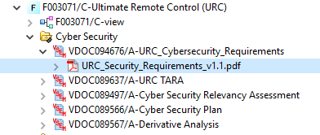

# Architecture

## Functional Architecture

**#Classification:** Mandatory for Functional Safety – otherwise optional

**#Hint**: This section depicts the coarse Functional Architecture. This architectural step is needed to find the right functional partitioning for the function level. The function shown here are those, which are specified on function level. Either SysML activity diagrams or Data Flow Diagrams could be used to depict such a Functional Architecture. For bigger features, which are decomposed in a hierarchical manner down to atomic functions (and which do not follow the Functional Safety process), a function tree could be given here.

**#Links:**

* Functional Decomposition: [RE Wiki – Functional Decomposition](http://wiki.ford.com/display/RequirementsEngineering/Functional+Decomposition)
* SysML - Activity Diagrams or [RE Wiki - Data Flow Diagrams](http://wiki.ford.com/display/RequirementsEngineering/Data+Flow+Diagram?src=contextnavpagetreemodehttp://wiki.ford.com/display/RequirementsEngineering/Data+Flow+Diagram?src=contextnavpagetreemode)
* Data Flow Diagram: [RE Wiki – Data Flow Diagram](http://wiki.ford.com/display/RequirementsEngineering/Functional+Decomposition)

URC Functional Decomposition:

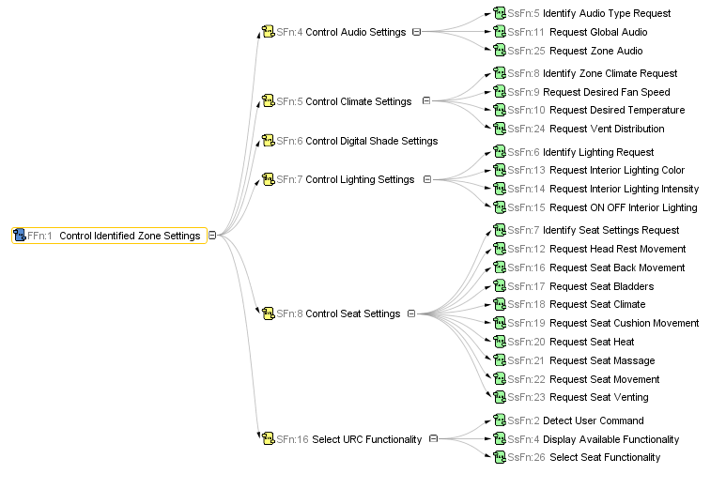



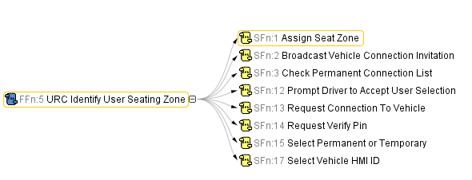

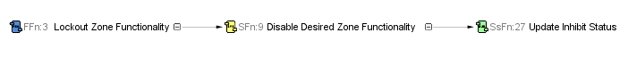

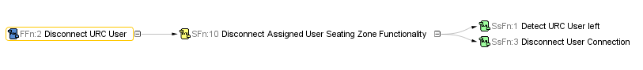

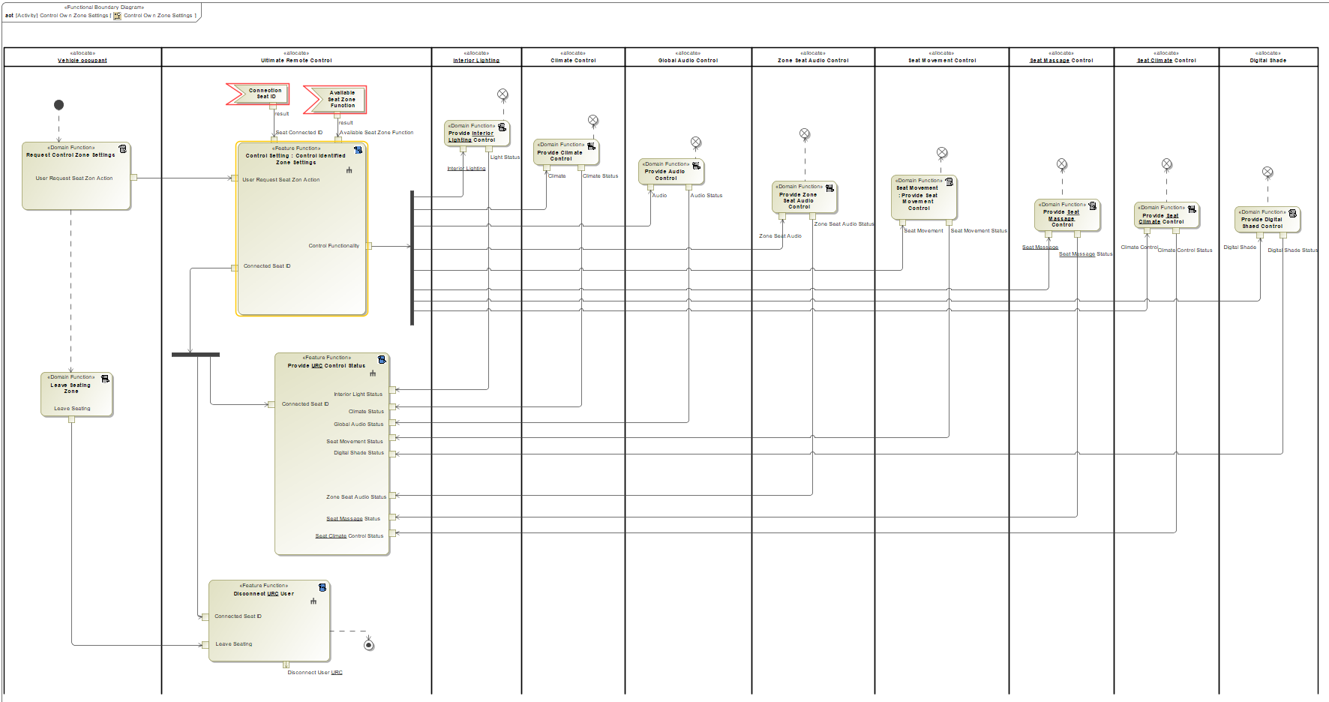

Figure 1: Control Own Zone Settings Use Case Feature Functions:

1. Control Identified Zone Settings
2. Provide URC Control Status
3. Disconnect URC User

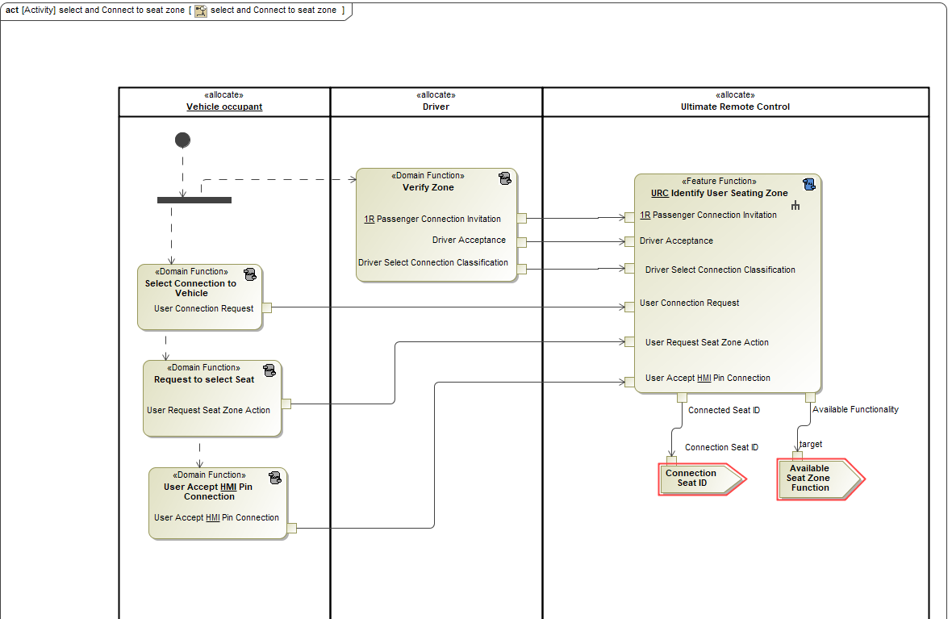

Figure 2: Select and Connect to Seating Zone Use Case Feature Functions

1. URC Identify User Seating Zone

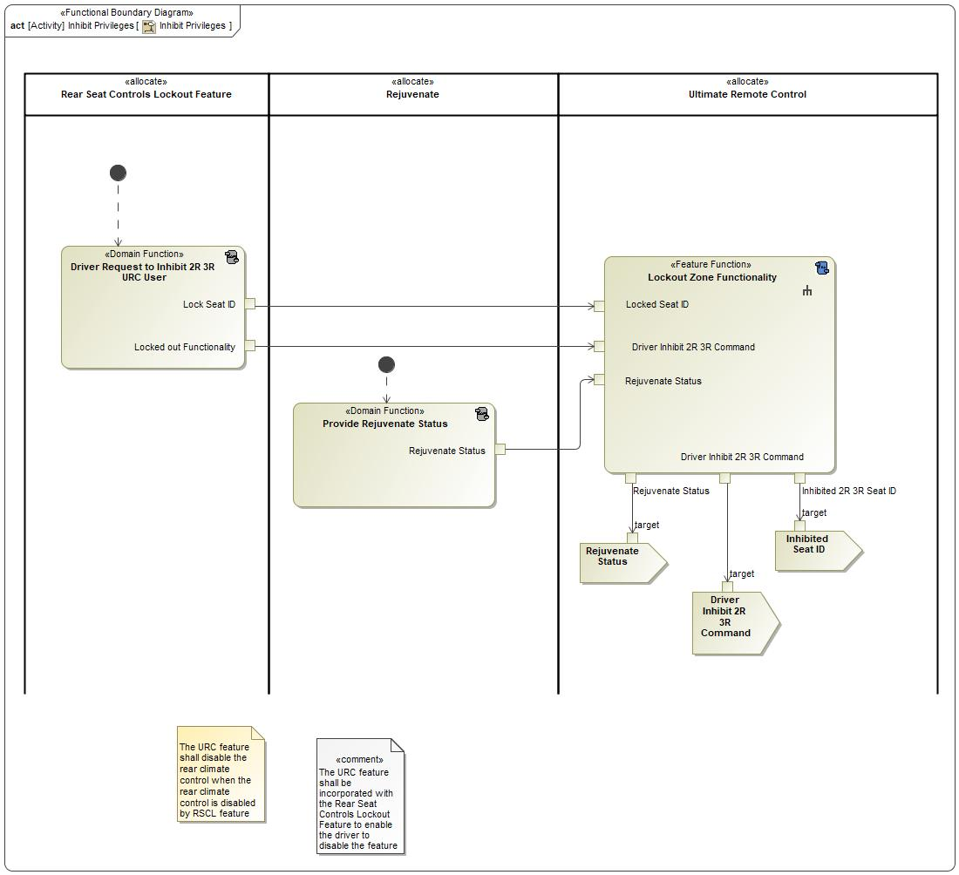

Figure 3: Inhibit Privileges Use Case Feature Functions

1. Lockout Zone Functionality

**See URC Function Specification for more System Level and Sub-System Level Function information**

### List of Functions

**#Hint:** The functions shown in the Functional Architecture should be listed and described in the table below

|  |  |  |  |
| --- | --- | --- | --- |
| **Function ID** | **Function Name** | **Function Description** | **ASIL** |
| SFn:1 | -1695729448.jpg Assign Seat Zone <<System Function>> | System Function "Assign Seat Zone" is to assign URC User's seat zone |  |
| SFn:2 | -1695729448.jpg Broadcast Vehicle Connection Invitation <<System Function>> | System Function "Broadcast Vehicle Connection Invitation" advertises an invitation for URC users to connect to the infotainment system |  |
| SFn:3 | -1695729448.jpg Check Permanent Connection List <<System Function>> | System Function "Check Permanent Connection List" searches to see if a connecting URC user is a permanent user in the infotainment system |  |
| SFn:4 | -1695729448.jpg Control Audio Settings <<System Function>> | System Function “Control Audio” for the URC users to control audio settings |  |
| SFn:5 | -1695729448.jpg Control Climate Settings <<System Function>> | System Function “Control Climate” for the URC users to control zone climate settings |  |
| SFn:6 | -1695729448.jpg Control Digital Shade Settings <<System Function>> | System Function “Control Digital Shade” for the URC users to control zone shade area on sunroof |  |
| SFn:7 | -1695729448.jpg Control Lighting Settings <<System Function>> | System Function “Control Lighting” for the URC users to control zone lighting settings |  |
| SFn:8 | -1695729448.jpg Control Seat Settings <<System Function>> | System Function “Control Seat Settings” for the URC users to control zone seat settings that consists of seat movement, seat climate, and seat massage |  |
| SFn:9 | -1695729448.jpg Disable Desired Zone Functionality <<System Function>> | System Function “Disable Desired Zone Functionality” Allows Driver/Passenger disconnect URC functionality |  |
| SFn:10 | -1695729448.jpg Disconnect Assigned User Seating Zone Functionality <<System Function>> | System Function "Disable Zone Seating Functionality" for the URC users to disables URC controls when the user leaves the seating zone |  |
| SFn:11 | -1695729448.jpg Display URC Status <<System Function>> | System Function "Display URC Status" shows the status of each control to URC User on the URC HHD app |  |
| SFn:12 | -1695729448.jpg Prompt Driver to Accept User Selection <<System Function>> | System Function "Prompt Driver to Accept User Selection" shows a pop-up to the driver in the infotainment system to accept/decline connecting URC Users |  |
| SFn:13 | -1695729448.jpg Request Connection To Vehicle <<System Function>> | System Function "Request Connection to Vehicle" is the initial request from a URC User to connect to the vehicle |  |
| SFn:14 | -1695729448.jpg Request Verify Pin <<System Function>> | System Function "Request Verify Pin" asks the connecting URC User to verify a Pin matches the infotainment screen on initial connection |  |
| SFn:15 | -1695729448.jpg Select Permanent or Temporary <<System Function>> | System Function "Select Permanent or Temporary" asks the Driver to classify the connecting URC User on the infotainment system |  |
| SFn:16 | -1695729448.jpg Select URC Functionality <<System Function>> | System Function” Select URC Functionality” for the URC Users to select the desired function to control. URC functionality composed of: lighting, audio, seat settings, and climate. Also, drive can select to inhibit the mentioned seat zone functionality |  |
| SFn:17 | -1695729448.jpg Select Vehicle HMI ID <<System Function>> | System Function "Select Vehicle HMI ID" Prompts the URC User to select the infotainment system ID they are connecting too |  |
| SFn:18 | -1695729448.jpg Update URC Status <<System Function>> | System Function “Update URC Status” updates User’s URC control status of climate, audio, seat, lighting |  |
| SsFn:1 | 1597650228.jpg Detect URC User left <<Subsystem Function>> | Subsystem Function "Detect URC User Left" detects if a URC user if they have left the vehicle with connectivity range |  |
| SsFn:2 | 1597650228.jpg Detect User Command <<Subsystem Function>> | Subsystem Function "Detect User Command" detects URC User's Command |  |
| SsFn:3 | 1597650228.jpg Disconnect User Connection <<Subsystem Function>> | Subsystem Function "Disconnect User Connection" disconnects a URC user |  |
| SsFn:4 | 1597650228.jpg Display Available Functionality <<Subsystem Function>> | Subsystem Function "Display Available Functionality" shows the content and status of each control function in a URC User's zone |  |
| SsFn:5 | 1597650228.jpg Identify Audio Type Request <<Subsystem Function>> | Subsystem Function "Identify Seat Zone Audio Request" to identify URC user's request to control seat zone audio |  |
| SsFn:6 | 1597650228.jpg Identify Lighting Request <<Subsystem Function>> | Subsystem Function "Identify Lighting Request" identifies the interior lighting request to select which light type URC user want to control (headliner lighting switch actuation, On/Off door lighting switch actuation, On/Off cup holder lighting actuation, and On/Off by feet lighting actuation). This will include setting the lighting scheme, lighting color, light intensity, light on off |  |
| SsFn:7 | 1597650228.jpg Identify Seat Settings Request <<Subsystem Function>> | Subsystem Function "Identify Seat Settings Request" defines which of the seat settings URC user wanted to control: Seat Movement, Seat Heat/Cool, or Seat Massage |  |
| SsFn:8 | 1597650228.jpg Identify Zone Climate Request <<Subsystem Function>> | Subsystem Function "Identify Zone Climate Request" defines URC user's Climate Control to request: Desired Temperature, Desired Fan Speed, Vent Distribution, or Temperature Unit |  |
| SsFn:9 | 1597650228.jpg Request Desired Fan Speed <<Subsystem Function>> | Subsystem Function "Request Desired Fan Speed" request desired fan Speed |  |
| SsFn:10 | 1597650228.jpg Request Desired Temperature <<Subsystem Function>> | Subsystem Function "Request Desired Temperature" request desired temperature |  |
| SsFn:11 | 1597650228.jpg Request Global Audio <<Subsystem Function>> | Subsystem Function "Request Sound Audio" URC User requests desired global audio controls |  |
| SsFn:12 | 1597650228.jpg Request Head Rest Movement <<Subsystem Function>> | Subsystem Function "Request Head Rest Movement" URC User requests to move seat headrest position |  |
| SsFn:13 | 1597650228.jpg Request Interior Lighting Color <<Subsystem Function>> | Subsystem Function “Request Interior Lighting Color” URC User requests to update color |  |
| SsFn:14 | 1597650228.jpg Request Interior Lighting Intensity <<Subsystem Function>> | Subsystem Function "Request Desired Temperature" URC User requests desired light intensity |  |
| SsFn:15 | 1597650228.jpg Request ON OFF Interior Lighting <<Subsystem Function>> | Subsystem Function “Request on/off interior lighting” URC User request to turn on/off the lighting in user’s zone |  |
| SsFn:16 | 1597650228.jpg Request Seat Back Movement <<Subsystem Function>> | Subsystem Function "Request Seat Back Movement" URC User requests to move seat back recliner position |  |
| SsFn:17 | 1597650228.jpg Request Seat Bladders <<Subsystem Function>> | Subsystem Function "Request Seat Bladders" URC User requests to adjust the seat lumbar via bladder inflation |  |
| SsFn:18 | 1597650228.jpg Request Seat Climate <<Subsystem Function>> | Subsystem Function "Request Seat Heat/Cool" request desired seat heat/cool settings |  |
| SsFn:19 | 1597650228.jpg Request Seat Cushion Movement <<Subsystem Function>> | Subsystem Function "Request Seat Cushion Movement" URC User requests to move seat cushion position (Fore/aft, up/down, tilt) |  |
| SsFn:20 | 1597650228.jpg Request Seat Heat <<Subsystem Function>> | Subsystem Function "Request Seat Heat" URC User requests to update Seat Heat level |  |
| SsFn:21 | 1597650228.jpg Request Seat Massage <<Subsystem Function>> | Subsystem Function "Request Seat Massage" request desired seat massage settings |  |
| SsFn:22 | 1597650228.jpg Request Seat Movement <<Subsystem Function>> | Subsystem Function "Request Seat Movement" request desired seat movement settings |  |
| SsFn:23 | 1597650228.jpg Request Seat Venting <<Subsystem Function>> | Subsystem Function "Request Seat Venting" URC User requests to update Seat Vent level |  |
| SsFn:24 | 1597650228.jpg Request Vent Distribution <<Subsystem Function>> | Subsystem Function "Request Vent Distribution" request desired Vent distribution |  |
| SsFn:25 | 1597650228.jpg Request Zone Audio <<Subsystem Function>> | Subsystem Function “Request Zone Audio” URC User request to control individual audio (Seat Speakers) |  |
| SsFn:26 | 1597650228.jpg Select Seat Functionality <<Subsystem Function>> | Subsystem Function “Select Seat Functionality” URC User to select available seat zone functionality |  |
| SsFn:27 | 1597650228.jpg Update Inhibit Status <<Subsystem Function>> | Subsystem Function “update Inhibit Status” to update the driver status of inhibiting 2R and 3R URC user’s available functionality |  |

## Logical Architecture

**#Classification:** Functional Safety Analysis only

**#Hint:** FS Analysis requires a description of the boundary of the feature and its elements. A simple block diagram or a SysML Internal Block Diagram could be used to depict the Logical Architecture

***#Link:*** [*Ford Functional Safety Sharepoint*](https://pd3.spt.ford.com/sites/GlobalFunctionalSafety/Pages/default.aspx)

URC Logical BD

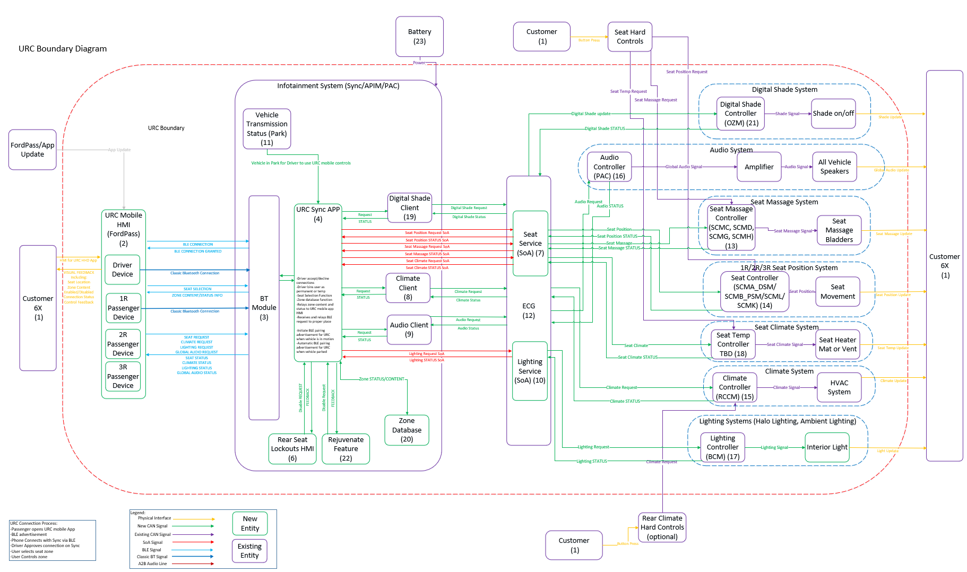

Figure 1: Logical BD

Link to Logical BD in VSEM:

<https://www.vsemweb.ford.com/tc/launchapp?-attach=true&-s=226TCSession&-o=iaoBzfezx3NrTDAAAAAAAAAAAAA&servername=Production_Server>

### Logical Elements

**#Hint:** Lists the elements of the Logical Architecture and the functions from the Functional Architecture, which are allocated to those elements.

|  |  |  |  |
| --- | --- | --- | --- |
| **Element Name** | **Description** | **Allocated Functions** | **Comments** |
| Audio System | Accepts Audio update requests from URC | * Control Audio Settings * Identify Audio Type Request |  |
| Climate Control System Controller | Accepts Climate update requests from URC | * Control Climate Settings * Identify Zone Climate Request |  |
| Digital Shade System Controller | Accepts Digital Shade update requests from URC | * Control Digital Shade Settings * Identify Digital Shade Request |  |
| URC HHD | URC Controller on the HHD | * Display URC Status * Request Connection To Vehicle * Request Verify Pin * Select URC Functionality * Select Vehicle HMI ID * Request Desired Fan Speed * Request Desired Temperature * Request Global Audio * Request Head Rest Movement * Request Seat Back Movement * Request Seat Bladders * Request Seat Climate * Request Seat Cushion Movement * Request Seat Heat * Request Seat Massage * Request Seat Movement * Request Seat Venting * Request Vent Distribution * Request Verify Pin * Request Zone Audio |  |
| Ultimate Remote Control on Infotainment System/ InvehicleHMI | URC on Infotainment System | * Assign Seat Zone * Check Permanent Connection List * Disable Desired Zone Functionality * Disconnect Assigned User Seating Zone Functionality * Prompt Driver to Accept User Selection * Select Permanent or Temporary * Update URC Status * Display URC Status |  |
| Lighting System  Controller | Accepts lighting update requests from URC | * Control Lighting Settings * Identify Lighting Settings Request |  |
| Seat System Controller | Accepts seat update requests from URC | * Control Seat Settings * Identify Seat Settings Request |  |
| Vehicle Connectivity System | Manages URC connections | * Broadcast Vehicle Connection Invitation |  |
| Vehicle Status Provider System | Updates URC with the correct status of features URC is controlling | * Provide Control Status to URC |  |

Table 19: Logical Elements

### Logical Interfaces

**#Hint:** Describe the interactions of the feature with other features or elements.

|  |  |
| --- | --- |
| Rejuvenate Feature | Rejuvenate Status: Active - will disable certain URC Functionailty |
| Portable Personal Profiles (PPP) | For MVP, URC has no interaction with PPP, in the future URC could enable passenger portable profiles |
| My Seat Space | URC is the main remote or controller for Zone Audio/MSS functions |
| Rear Seat Controls Lockout Feature | URC will be in the RSCL menu so Driver/1R Passenger can disable URC Users quickly |

# Open Concerns

**#Hint:** The following list presents open concerns, which have to be discussed or clarified over the course of the on-going requirements engineering.

| ID | Concern Description | e-Tracker / Reference | Responsible | Status | Solution |
| --- | --- | --- | --- | --- | --- |
| 1 |  |  |  |  |  |

Table 20: Open Concerns *(Not supported by MagicDraw report generation)*

# Revision History

**#Hint:** A new version number is assigned to a document with a given revision each time it is checked in to Team Center (TCSE). After release of a revision, the document cannot be edited and no new versions can be created on that revision. When updating the document after that, a new revision has to be created and new versions on that revision will be created upon checking in.

No Revision History found.

## Template Revisions

*#Important: Do not change this section*

|  |  |  |  |  |
| --- | --- | --- | --- | --- |
| Version | Rev. | Date | Description | Responsible |
| *0* | *6* | *2015-05-26* | * *Chapter “Feature Overview” and made a 2nd level heading.* * *Chapter “Feature Modeling” divided into 3 subchapter (“Scenarios”, “Use Cases”, “State Machines”) for different modeling methods* | *Jbaden1* |
| *0* | *7* | *2015-05-27* | * *Table of Content updated* * *Template Revision History chapter added* | *Jbaden1* |
| *0* | *8* | *2015-07-02* | * *Section “Unsettled Issues” added* | *Alevin7* |
| *0* | *9* | *2015-08-04* | * *Section “Feature Variants” added* * *Section “Feature Boundary Diagram” renamed to “Feature Context Diagram”* * *Document Properties adapted to match needs of VBA macros* | *Jbaden1, Awegman1* |
| *1* | *0* | *2015-09-11* | * *Section “Feature Variants” reworked* * *Feature Goals removed. Only “Safety Goals“ chapter remains.* * *Heading 2 formatting issues corrected.* * *Requirements / Use Cases Listing removed from traceability chapter.* * *Formatting of attribute table in Notation chapter corrected* * *Open Topics / Known Issues chapter moved to the end* | *Jbaden1* |
| *1* | *1* | *2015-11-16* | * *Table-Styles removed (for smooth VSEM import)* * *Some clean-up of sections “Purpose” and “Audience”* | *Awegman1, jbaden1* |
| *1* | *2* | *2016-02-26* | * *Minor corrections based on lessons learned from CC and PCL pilot (e.g. section market/regions) and discussion with Functional Safety Team (purpose of feature)* * *Footer corrected* * *Boundary diagram interface chapter renamed to influences.* | *Jbaden1* |
| *1* | *3* | *2016-02-26* | * *Minor corrections after review with Whitney Keith from Functional Safety team* | *Jbaden1* |
| *1* | *4* | *2016-03-10* | * *Some cleanup of meta-data in Word Properties* | *Jbaden1* |
| *1* | *5* | *2016-03-10* | * *Footer formatting corrected (Issue 19)* * *Results from review with Functional Safety Team incorporated (Issue 20).* | *jbaden1* |
| *1* | *6* | *2016-04-18* | * *Scenario Template added* | *Jbaden1* |
| *1* | *7* | *2016-04-18* | * *Chapter “Operation Modes and States” moved before “Use Case” section.* | *Jbaden1* |
| *1* | *8* | *2016-04-18* | * *Broken Wiki links repaired.* | *Jbaden1* |
| *2* | *0* | *2016-05-19* | * *Adapted to Specification_Macros.dotm V2.0* * *Requirements Templates chapter (ch. 1.7.1) no longer has an attribute table, but refers directly to the Wiki..* | *Jbaden1* |
| *2* | *1* | *2016-06-10* | * *Table for Context Diagram modified (lists external entities and Influence Description only)* | *Jbaden1* |
| *2* | *2* | *2016-07-08* | * *Template version added to footer* * *Several hints added to the various sections* * *Findings from Functional Safety Team incorporated.* * *RE_SafetyRequirement style added* | *Jbaden1* |
| *2* | *3* | *2016-09-21* | * *Update from Functional Safety Team incorporated (“Lessons Learned”, “System Behaviors for HARA”)* | *Jbaden1* |
| *2* | *4* | *2016-11-15* | * *Update from Functional Safety Team incorporated (“Lessons Learned”, “System Behaviors for HARA”)* * *Explanatory notes made more formal* | *Jbaden1* |
| *3* |  |  | *Skipped to synchronize with Specification_Macros.dotm* |  |
| *4* |  |
| *5* | *0* | *2017-01-13* | * *Meta data updated for specification macros, version 3.1* * *SW Unit chapter removed for the time being* * *Green boxes added for user hints* | *Jbaden1* |
| *5* | *1* | *2017-01-18* | * *Minor editorial changes* | *Jbaden1* |
| *6* | *0* | *2017-02-03* | * *CR48: Chapter 6 renamed from “Safety” to “Functional Safety”. New sub-chapter “Safety” introduced in Non-Functional Requirements section* | *Jbaden1* |
| *6* | *0* | *2017-04-28* | * *CR7: “RequirementsTraceability” chapter removed* | *Jbaden1* |
| *6* | *0* | *2017-11-15* | * *CR32/53: New Cover Sheet + Disclaimer replaces FAP-150 like ones.* * *CR75: Some rewording -> Terminology to Glossary, Notation -> Document Conventions* * *CR49: Rename “Assumptions & Constraints” to “Assumptions”* * *CR74: Safety Assumptions added to chapter 6.* * *CR58: Add function allocation column to Logical Architecture chapter* | *Jbaden1* |
| *6* | *0* | *2018-01-31* | * *CR63: Updated links to Functional Safety Sharepoint* | *Jbaden1* |
| *6* | *0* | *2018-07-24* | * *CR69: Add FSR to FeatureDoc* * *CR64: Add new section "Design Requirements" to Function Spec and Feature Spec* | *Jbaden1* |
| *6* | *0* | *2018-08-06* | * *CR53: some corrections for metada and formatting* | *Jbaden1* |
| *6* | *0* | *2018-09-28* | * *Broken links to RE Wiki repaired* | *Jbaden1* |
| *6* | *0* | *2018-10-31* | * *Cover sheet and footer more GIS like. Functional Safety team feedback incorporated:*   + *New subsections “Functional Safety Requirements, (Decomposed) FSRs and Parameters / Values*   + *Removal of “Logical Architecture”* | *Jbaden1* |
| *6* | *0* | *2018-12-12* | * *FSR template removed, now as a macro in the Specification_Macros.dotm* | *Jbaden1* |
| *N* |  | *2019-04-03* | * *Updated code for context diagrams, actors and use cases.* * *Updated code structure with all macros at the beginning.* * *Updated code to populate assumptions using element-assumption relationship or hazardous event.* | *snuesch* |
| *N* |  | *2019-04-18* | * *Added structural boundary diagram for FuSa based on TGB discussion.* * *Added operating modes to functional safety requirements.* | *snuesch* |
| *O* |  | *2019-04-25* | * *Improved export of actions and activities on functional boundary diagram.* | *snuesch* |
| *6* | *0b* | *2019-05-23* | * *Re-introduce “Logical Architecture” (for Functional Safety)* | *Jbaden1* |
| *O* |  | *2019-06-17* | * *Aligned “Architecture” section with RE template.* * *Made “Ford Documents” table more flexible.* * *Added template terms to glossary* | *snuesch* |
| *O* |  | *2019-06-25* | * *Improved use cases to handle Primary and Secondary actors.* * *Added Performance Requirements to Uncategorized.* | *snuesch* |
| *6* | *0b* | *2019-06-26* | * *Chapter “Logical Elements” in “Logical Architecture” section added (FuSa CR 15136240)* * *“References” and “Glossary” chapter moved from section “Feature Overview” to “Introduction”. References and Glossary should be available in the document as early as possible* | *Jbaden1* |
| *O* |  | *2019-07-25* | * *Added populated “Logical Elements” table and allocated functions.* * *Export documentation field of context diagram.* | *snuesch* |

# Appendix

## Definitions

| **Definition** | **Description** |
| --- | --- |
| Climate Zone | Number of Climate Zones defined by Climate System (One Zone, Dual Zone, Tri Zone, Quad Zone) URC user’s control the climate zone they are occupy |
| Digital Shade Feature | Digital Shade is a feature that allows different sections of the sunroof to be shaded by the Users |
| Interior Lighting | Interior lighting includes all interior ambient lightings. For URC to be able to control lighting the lights must be changeable by seating zone. |
| Permanent URC User | Re-occurring use of URC in a vehicle. User’s phone ID is stored in vehicle infotainment system in a permanent connection list until manual deletion or master reset. Example: Family vehicle |
| Portable Personal Profiles | Feature that saves a user’s profile and exports it off the vehicle into the cloud. A user’s profile can then be imported to a new vehicle |
| Rear Seat Controls Lockout Feature | Feature that provides a way for the Driver/1R passenger to disable rear seat occupants from controlling vehicle controls (Climate, Audio, URC) |
| Rejuvenate Feature | Feature that provides a “Rejuvenate” experience for the driver when the vehicle is stationary |
| Seat Climate | Seat heating or venting of the seat surface |
| Seat Massage | Seat Massage feature allows the control of massaging seats (Multi-Contour Seats) by inflating and deflating air bladders in the cushion and back of the seat |
| Seat Position Settings | The Seat settings consists of  a. Seat Power Movement  i. Cushion Movement – all available  1. Cushion track fore/aft  2. Cushion track up/down  3. Cushion track tilt  4. Cushion extension left  5. Cushion extension right  6. Calf Raise  ii. Seat Back Movement – all available  1. Back recline  2. Back upper pivot  3. Lumbar (Power Mechanical)  iii. Head Rest Movement  1. Head Rest fore/aft  2. Head Rest up/down  iv.Bladders  1. Back Bolster bladders  2. Cushion Bolster bladders  3. Lumbar (Bladders) |
| Seating Zone  Seating Area | A seating zone is defined by each outboard seat per row (left and right). Example: 6 seating zones for a 3 row vehicle |
| Stationary | Transmission in Park |
| Temporary URC User | Once time use of URC in a vehicle. User’s phone ID is not stored in vehicle infotainment system. Example: Riding to lunch or ride share. |
| URC User | Vehicle Occupants intending to use URC HHD App |
| Vehicle Occupant | Second or Third Row Passengers |
| Zone Audio  My Seat Space | Zone Audio adds Speakers to each outboard seat allowing the User individual audio functions (My Seat Space Feature):  a. In car communication ICC (Seat to Seat Communication)  b. Independent sound zones (My Seat Space, Individual Music Streaming)  c. Private Phone Call Localization  d. Shared music across zones (Media Sharing) |

Table 21: Definitions used in this document

## Abbreviations

| **Abbr.** | **Stands for** |
| --- | --- |
| 1R | First Row Occupant |
| 2R | Second Row Occupant |
| 3R | Third Row Occupant |
| ARL | Attribute Release Letter |
| A Status | Audio Status |
| C Status | Climate Status |
| L Status | Lighting Status |
| HHD | Hand Held Device |
| HMI | Human Machine Interface |
| MSS | My Seat Space |
| MVP | Minimal Viable Product |
| RSCL | Rear Seat Controls Lockout Feature |
| URC | Ultimate Remote Control |

Table 22: Abbreviations used in this document

Document ends here.